
AWS Lab 4-6
Ian Kwan - CCNA
Purpose

In the contemporary computing world, convenience and efficiency are the core values that drive the development of technology and novel innovations. From the development of Lunix, to the Windows updates, to the widespread use of VPNs for at-home access to office files and resources, society is built on these core values. Many of these developments fall into the category of software and cloud-based which will be the focus of this lab. In this lab, the focus will be to expand user knowledge and ability to use AWS cloud-based applications and services to develop and expand their own servers, maximizing convenience while maintaining efficiency.
Background
In simple terms a (VM) virtual machine is a system that operates within another device. VMs have their own provisioned resources and (OS) operating system. This is possible through a software call the hypervisor, also known as the (VMM) virtual machine monitor. Like its name, a VMM monitors and manages VMs, carrying the responsibility of provisioning and securing VMs. VMs have a built-in layer of security through VMMs, as they are separated from the host machine, meaning that even with penetration into the host machine, the VMs may not be compromised. And in the same sense, because VMs are separated from the host machine, if the VM is compromised, the host machine is protected.
VMs have multiple use cases. Some examples are maximizing the use of hardware resources, security experimentation, and cloud computing. Hardware resources—which include storage space, compute power, and physical space—are highly valuable and often costly for businesses. VMs help to maximize the use of each physical device, provisioning used resources to other VMs not wasting important business funds.
Through AWS, users can make VM-like systems through the cloud, mimicking an on-premises data center, through the Amazon (EC2) Elastic Compute Cloud Service. This provides users with access to the same services and capabilities of VMs while maintaining a cloud-based environment. Amazon EC2 uses a pay-as-you-go model, which minimizes unnecessary business costs by only charging for used resources, in comparison with on-premises data centers in which unused resources will cost the business.
In this lab the VM function of focus will be its storage capabilities. Using AWS cloud architecture, users will experiment with implementing volumes onto instances and using other AWS services to test AWS storage capabilities. But a limit to instance and VM storage is that if the host machine is turned off, all data will be lost as VMs, and instances will no longer be active. As a solution, Amazon also offers storage using other services, one of which is Amazon (EBS) Elastic Block Storage. This service offers block storage that operates independently of any instance, making storage more permanent.
On top of these services, a core benefit that AWS offers is scalability and load balancing. In an on-premises server, developers must purchase backup devices and resources in preparation for events like higher traffic or device failure. This can lead to additional financial costs for businesses. AWS offers services that automatically scale and load balance traffic on user servers in the cloud. This allows for users to save costs and focus on the develop of their business while AWS handles scaling and the operation for their websites and unexpected events where a server fails or is overloaded.
AWS is divided into multiple AWS Regions to offer users the ability to expand their reach to foreign regions across the globe. Across each regions, there are multiple Availability Zones that users can access. In each Availability Zone, developers can build their servers with AWS servers to run their businesses. Using AWS load balancing, developers can connect different Availability Zone together, to minimize the load on each individual zone and maximize the use of AWS services.

Configuration

Working with EBS
The goal of this lab is to explore core Amazon EBS functions including how to create, attach, mount, and snapshot an Amazon EBS volume. The lab will also dive into Amazon EC2 functions as it is closely connected to Amazon EBS functions.

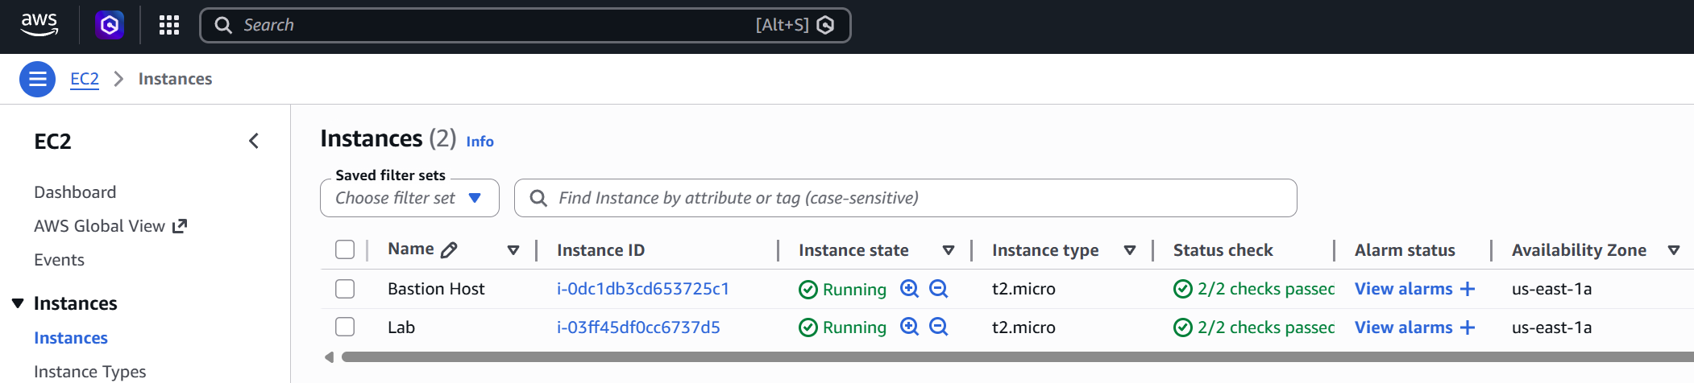First, we will create and attach a volume to an Amazon EC2 instance. To start, figure out what Availability Zone your EC2 instance is in. You can figure this out by navigating to the EC2 service and then to the Instance tab on the left side bar.

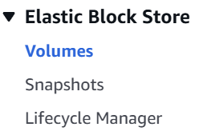
After figuring out the Availability Zone, navigate to the Volumes tab on the left side bar.

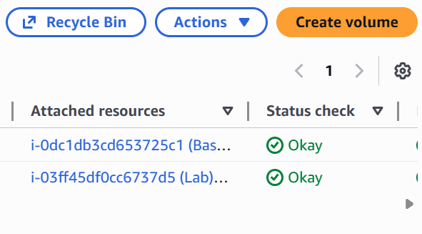
Next, in the top right corner of the Volumes tab, select “Create volume” to create the EBS volume.

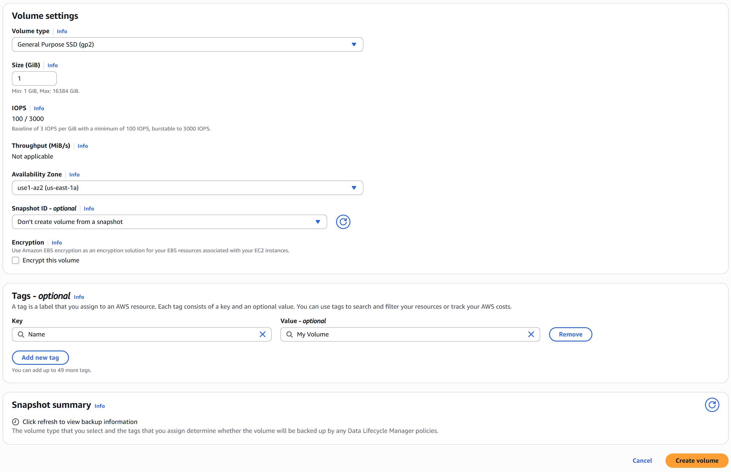
The next step is to configure the new EBS volume. Above, the desire configurations are displayed. The configurations are as follows: Volume type, gp2; Size, 1 GiB; Availability Zone, same as the Lab EC2 instance; Tag Key, Name; Tag Value, My Volume. To create a Tag, click “Add a new tag”. After configuring the proper settings, select “Create volume”.

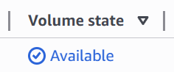
After creating the volume, a green banner will notify that the volume has been created. Next, select the refresh icon until My Volume’s Volume state switches to Available.

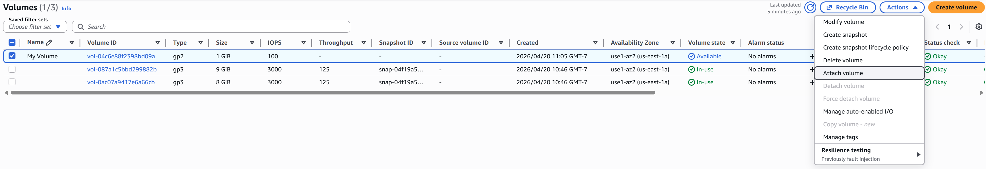
Next select the My Volume instance and choose “Attach volume” from the Actions dropdown menu.
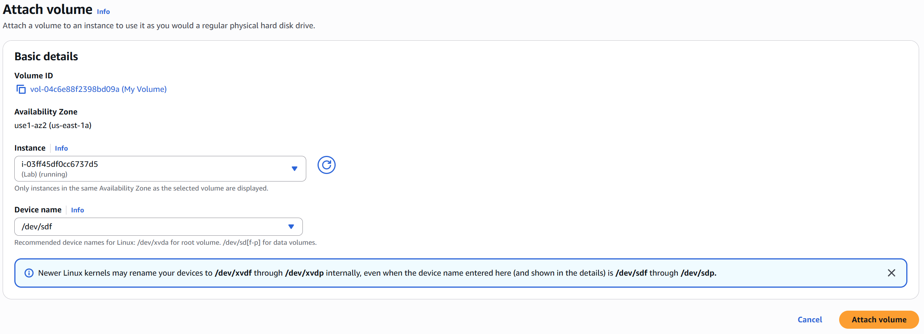
Above the configurations to properly attach the volume to the EC2 instance. Under Instance, select the Lab instance. Under Device name, type and select “/dev/sdf”. Then select “Attach volume”.

To begin configuring this volume, navigate back to the instance tab on the left side bar and select the lab instance. Then, select “Connect”.

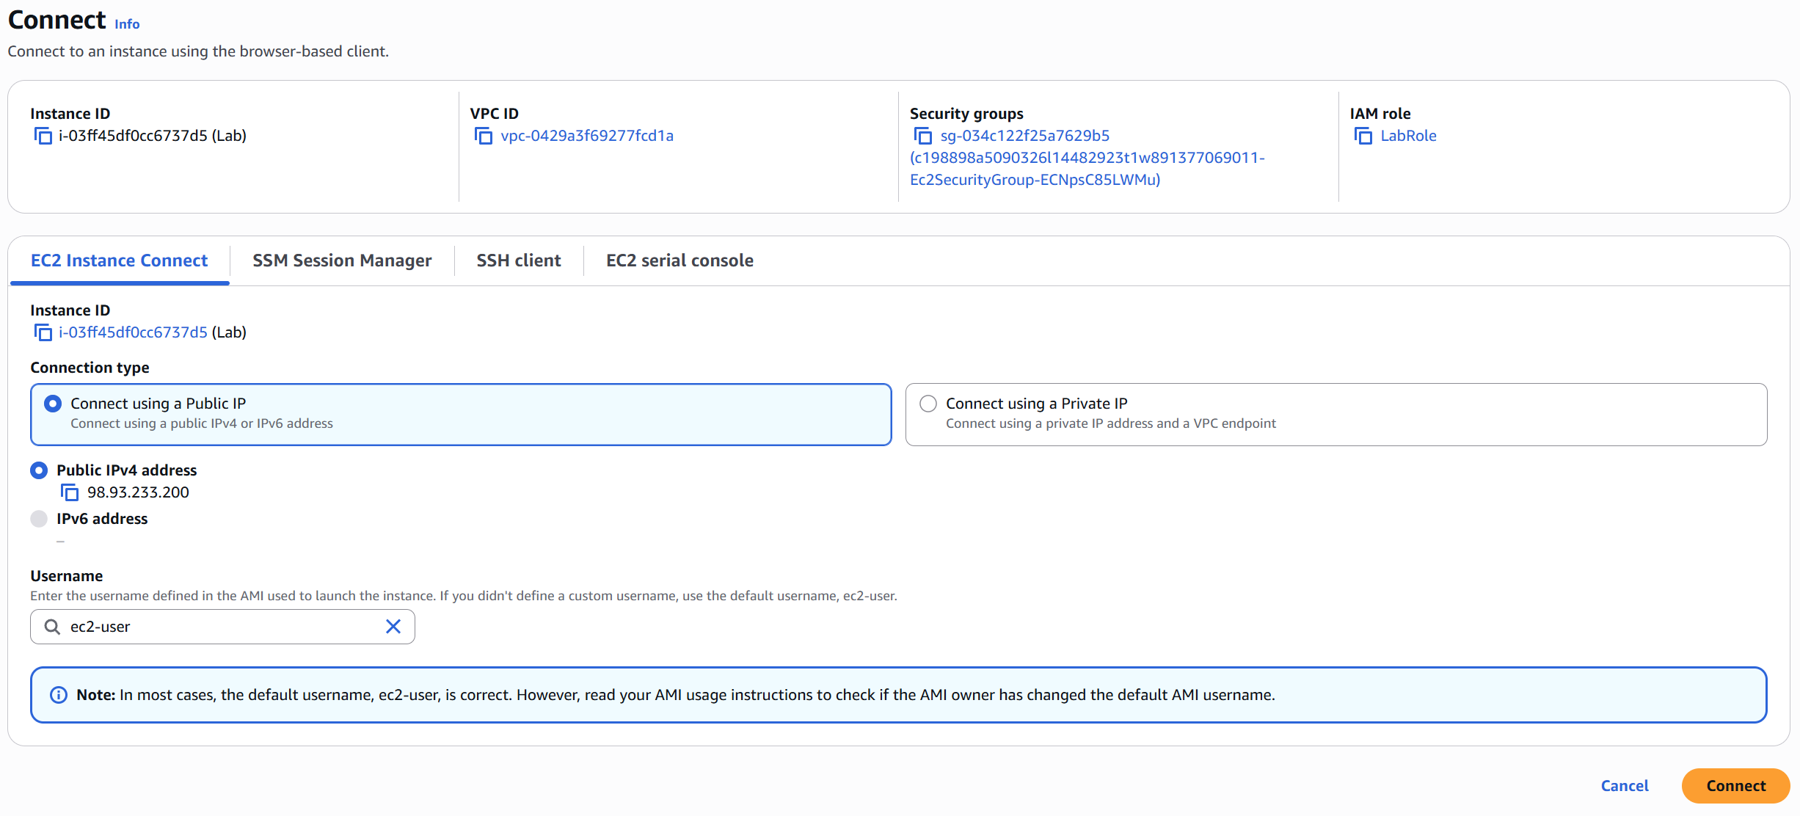
Next, select “Connect” again.

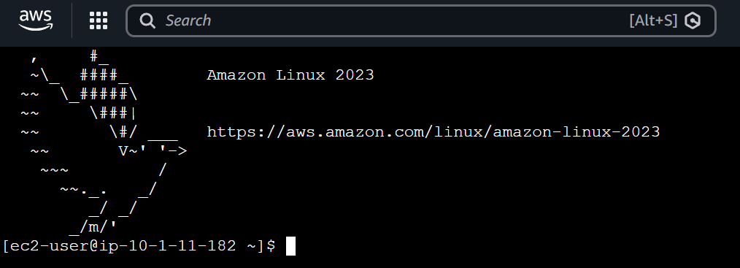
Congratulations, you have navigated and successfully created an Amazon EBS volume.

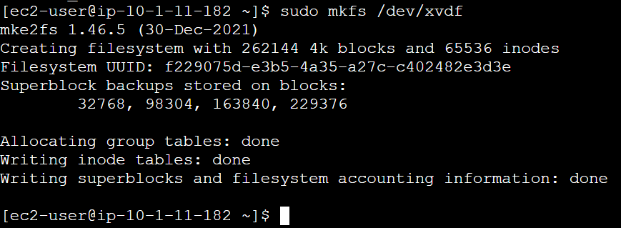
We will begin to create a File system. Type in the command: sudo mkfs /dev/xvdf. Even though /dev/xvdf is analogous to /dev/sdf, creating the same system, only the first configuration will get credit in this lab.

The first configuration will create a directory for the file system. The second configuration will mount the file system to the new volume created.

This command shown above would represent what a user would do to permanently mount the file system onto the instance every time it boots up.

This command shown above adds a text file to the file system the user has just mounted.

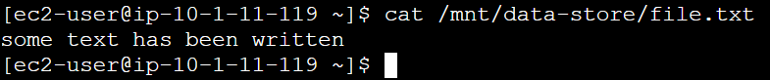
To view the file’s contents, type the command shown above. Congratulations, our exploration of volumes is finished. Now we will move onto Snapshots.

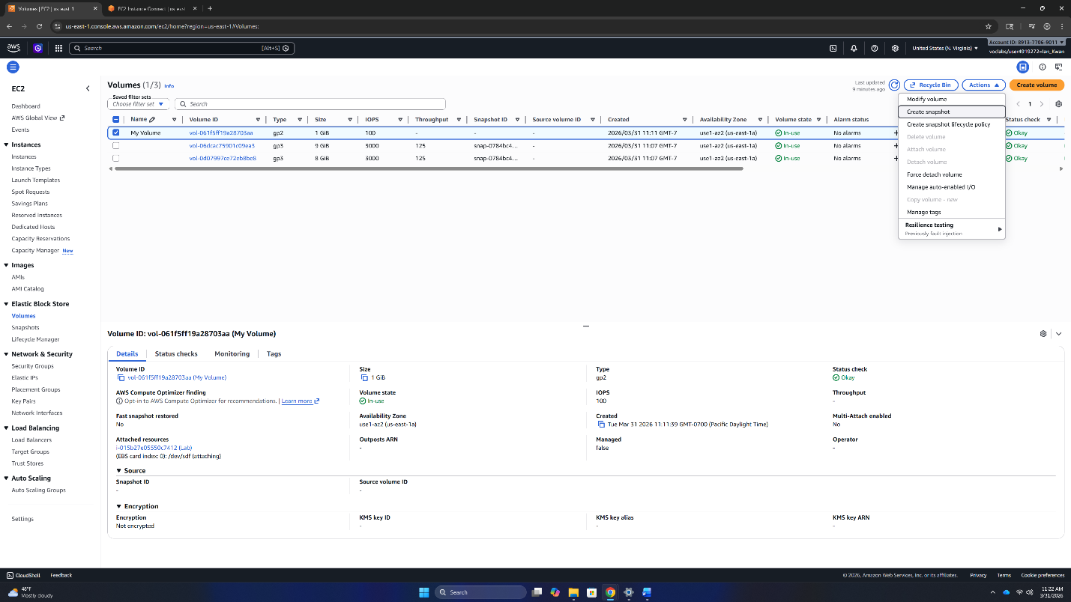
Navigate back over to the EC2 configuration tab and over to the Volumes tab on the left side bar. Then, select My Volume and under the dropdown menu from Actions, select create a snapshot.

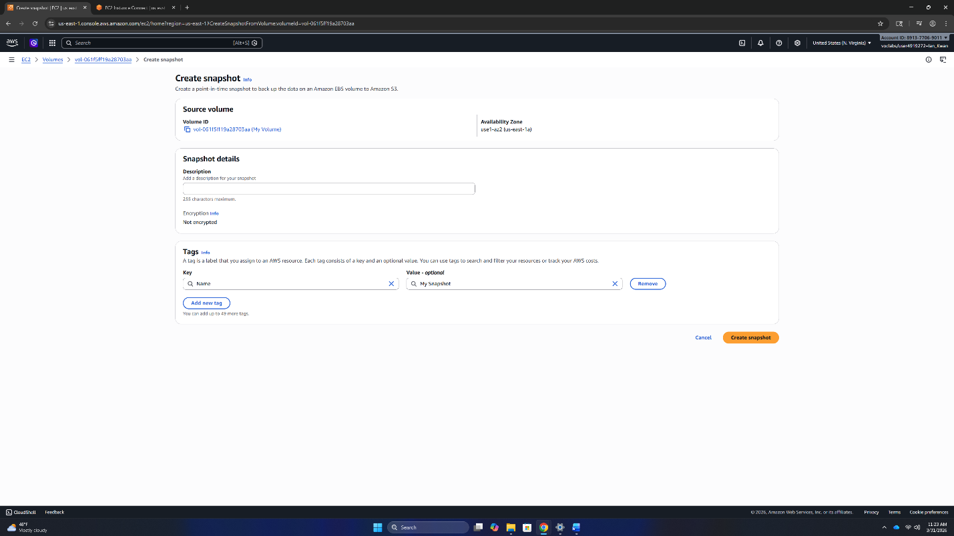
Next, configure a tag for the snapshot. Type “Name” for the Tag Key and “My Snapshot” for the Tag Value. Then, select “Create snapshot”.

Now, we are going to simulate a scenario where our data has been deleted. Navigate back to the instance configuration tab and type in the following command. This command deletes the text file we created earlier.

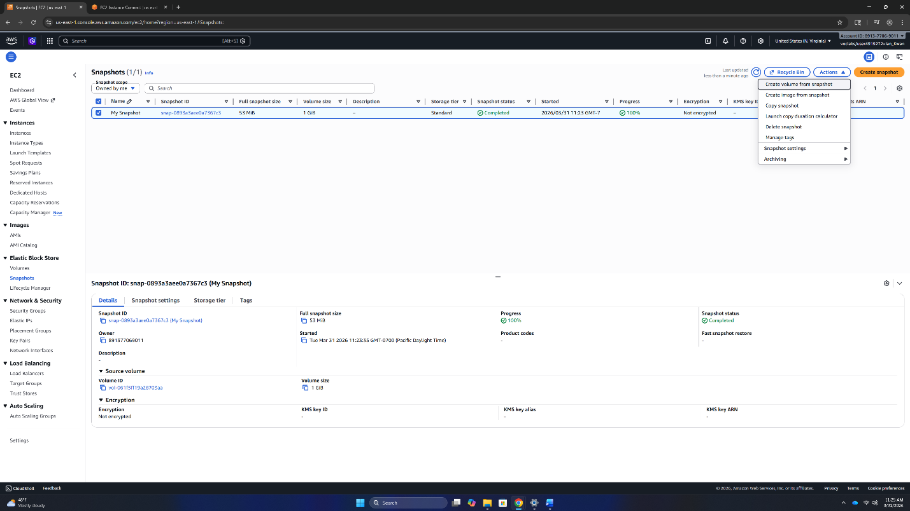
Navigate to the Snapshots tab on the left side bar and verify that My Snapshot’s status is Completed. If it isn’t, click the refresh icon in right corner next to the recycle bin icon. Then, select the snapshot and select “Create volume from snapshot” under the Actions dropdown menu.

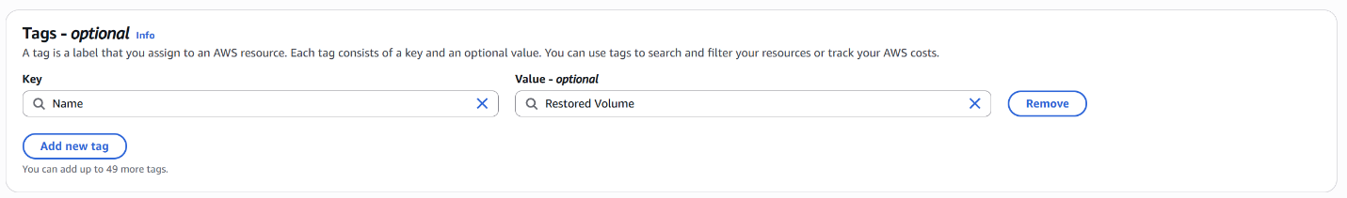
In this lab, the only thing we will need to configure is the tag. Type “Name” for the tag key and “Restored Volume” for the tag value. Then select, “Create volume”.

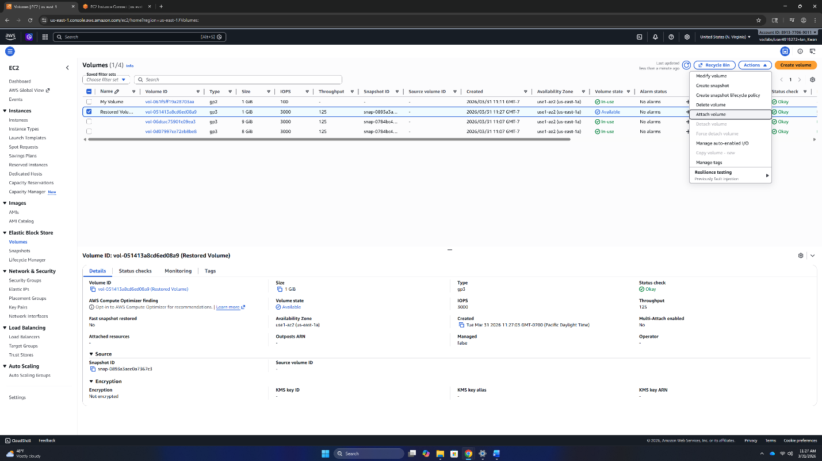
Next, go to the volumes tab on the left side bar. Select the Restored Volume once its status switches to available. If it hasn’t updated, you can refresh by clicking the refresh icon in the right upper corner. Then, select Attach volume under the Actions dropdown menu.

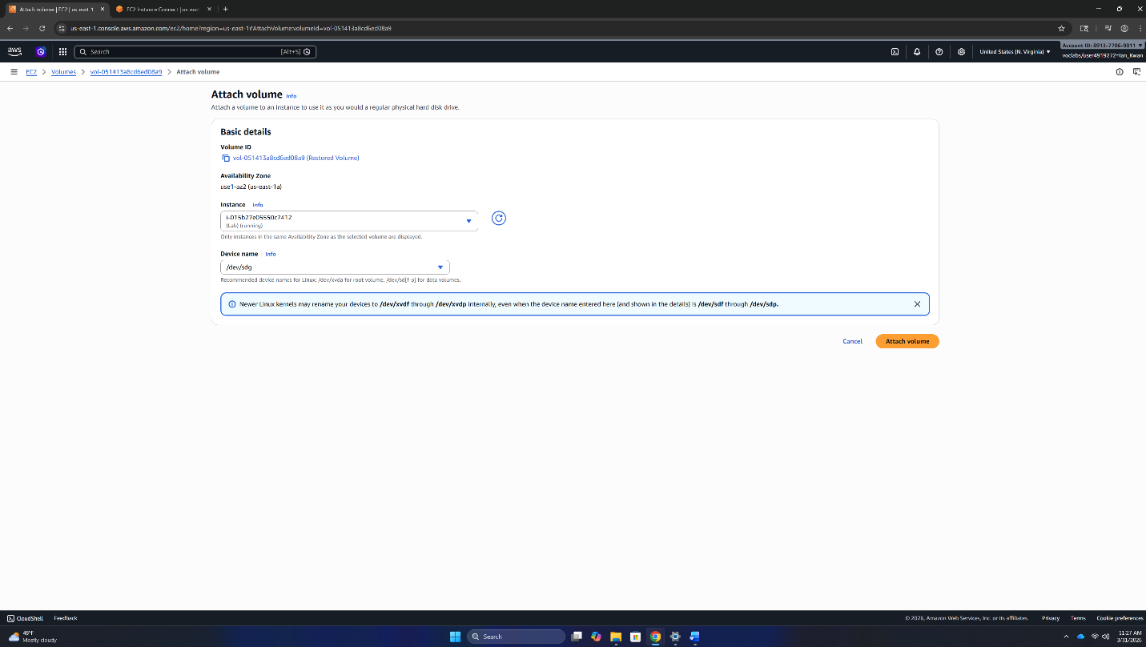
Select the Lab instance as the instance the volume should attach to and set the device name to /dev/sdg. Then, select “Attach volume”.

Type in the above storage volume to begin the mounting process.

Then mount the volume with the above command.

Then verify that the text file is in the volume you have mounted with this command. Congratulations, you have successfully completed Lab 4: Working with EBS.

Build a Database Server
First, we will work on creating a security group to allow the AWS services to interact together. Next, we will create a DB subnet group and open the web application that is running on the web server.
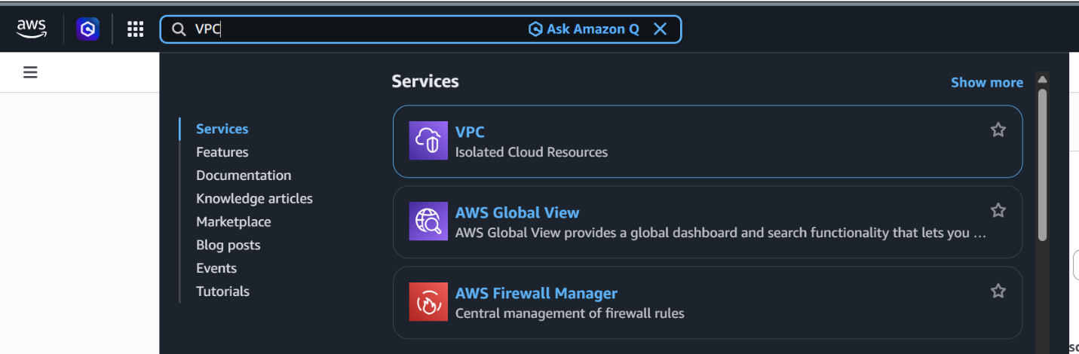
To create the security group, navigate to the AWS VPC service. Type VPC into the search bar and select VPC.

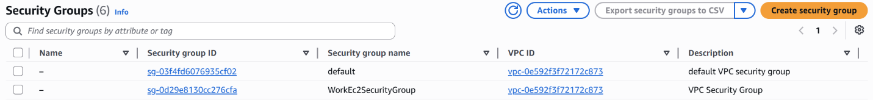
In the Security Group tab, select Create security group.

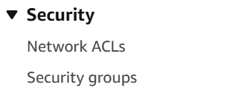
On the left-side bar, under Security, select Security groups.

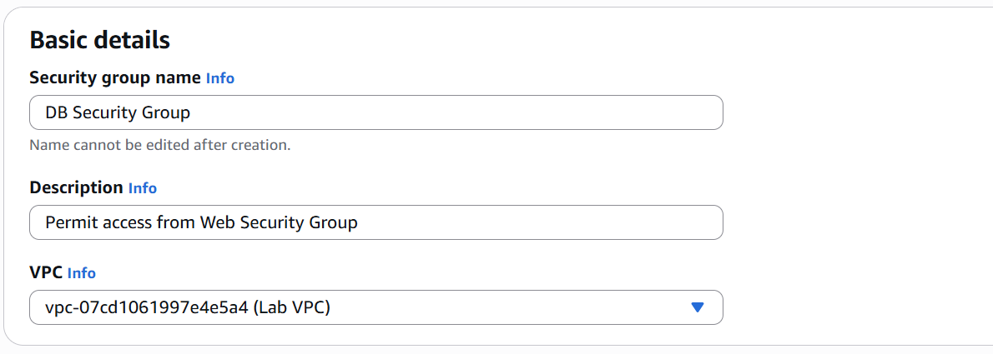
Name the Security Group “DB Security Group”. Add “Permit access from Web Security Group” to the Description. Then, select Lab VPC as the VPC.

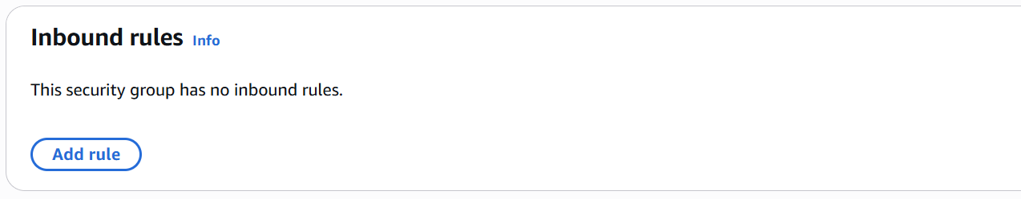
Add an inbound rule by selecting the Add rule icon.

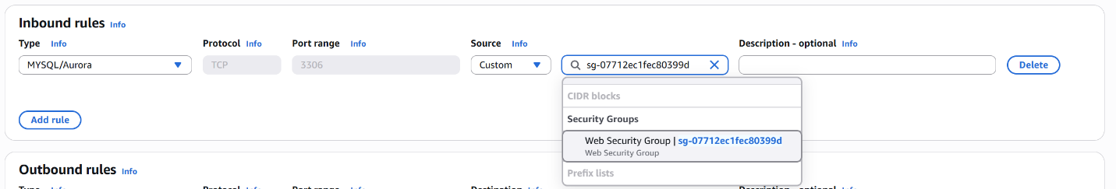
Select MYSQL/Aurora as the Type. Under Source, making sure that Custom is selected as the left input, search for and select Web Security Group in the search bar.


Then scroll down and select Create security group.

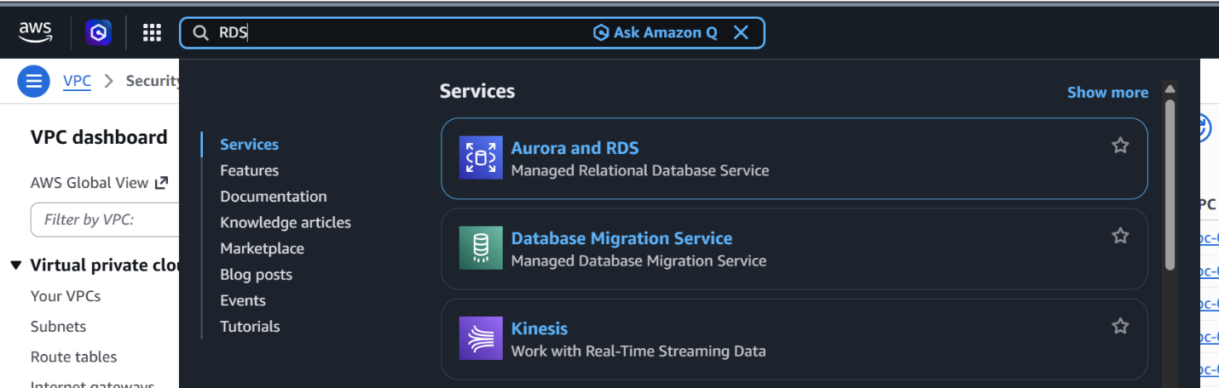
After creating the Security Group, we now move onto creating the Relational Database. Search for RDS in the main search bar, then select Aurora and RDS.

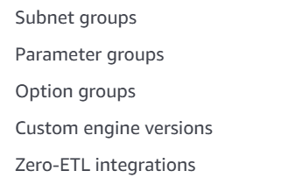
From the left-side bar, select subnet groups.

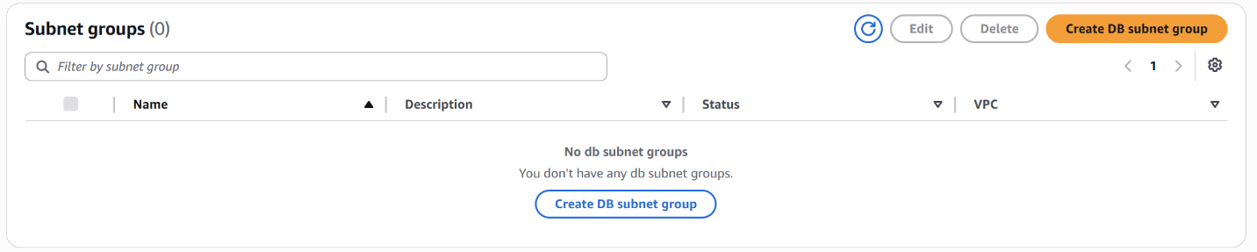
From the Subnet groups tab, select Create DB subnet group.

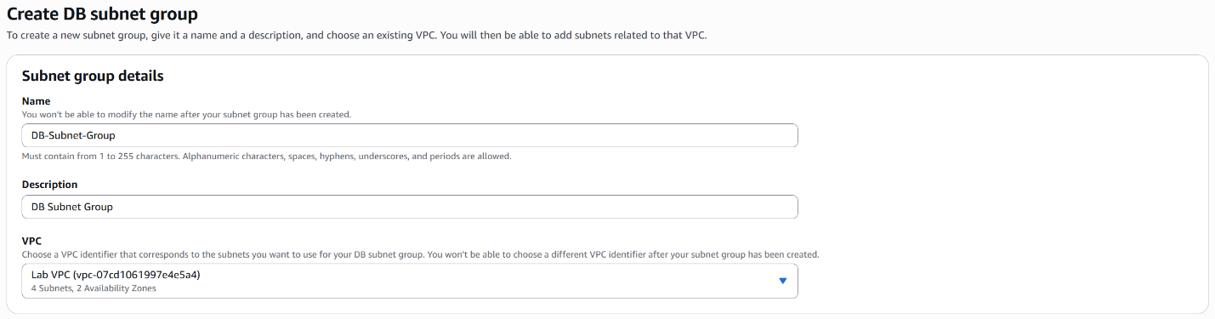
Name your Subnet group DB-Subnet-Group. Add DB Subnet Group to the Description. And Select Lab VPC as the VPC.

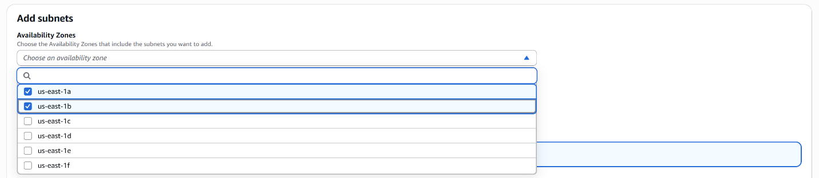
Under Add subnets, click on Choose an availability zone, select us-east-1a and us-east-1b.

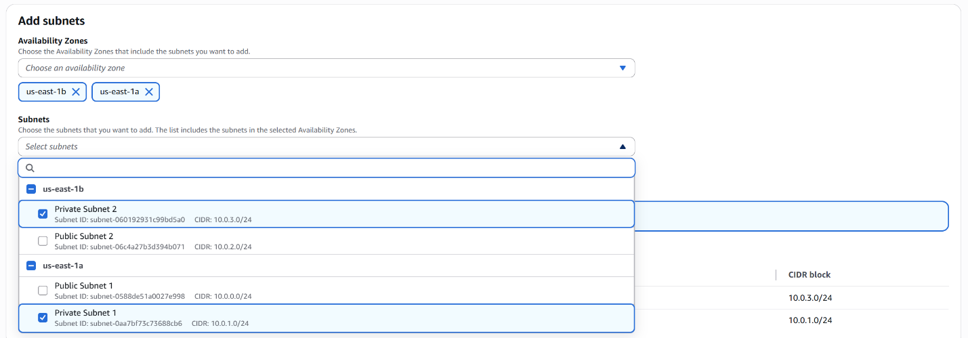

Then, under subnets, click Select subnets, and select Private Subnet 2 and Private Subnet 1.

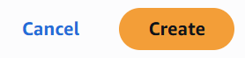
Then, scroll down and select Create.

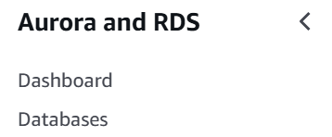
Back in the Aurora and RDS service main menu, select Databases in the left-side bar.

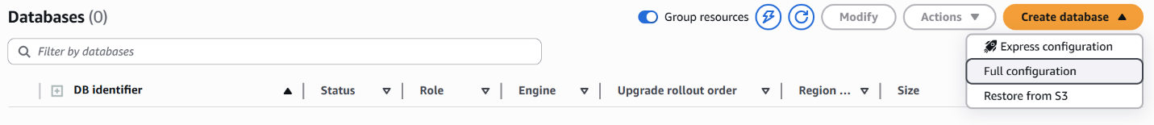
In the Database tab, select Create database and then Full configuration from the drop-down menu.

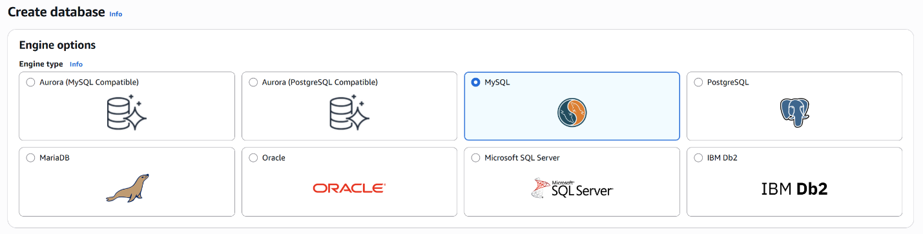
Under Engine type, select My SQL.

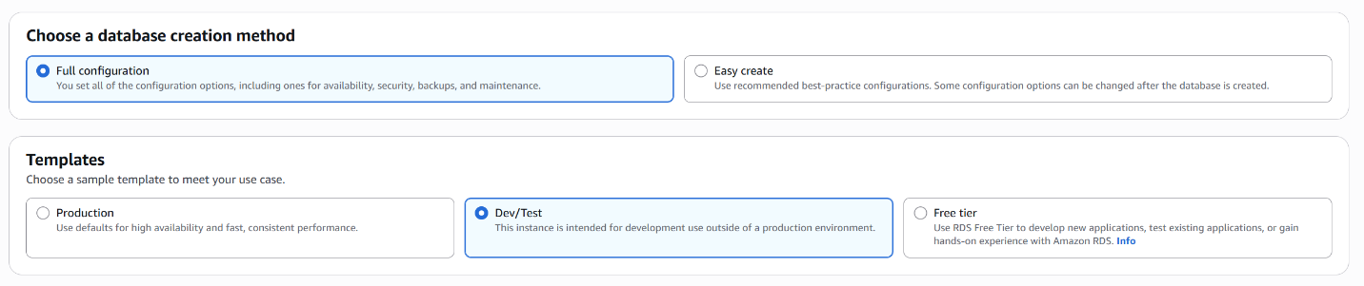
Under Choose a database creation method, select Full configuration. Under Templates, select Dev/Test.

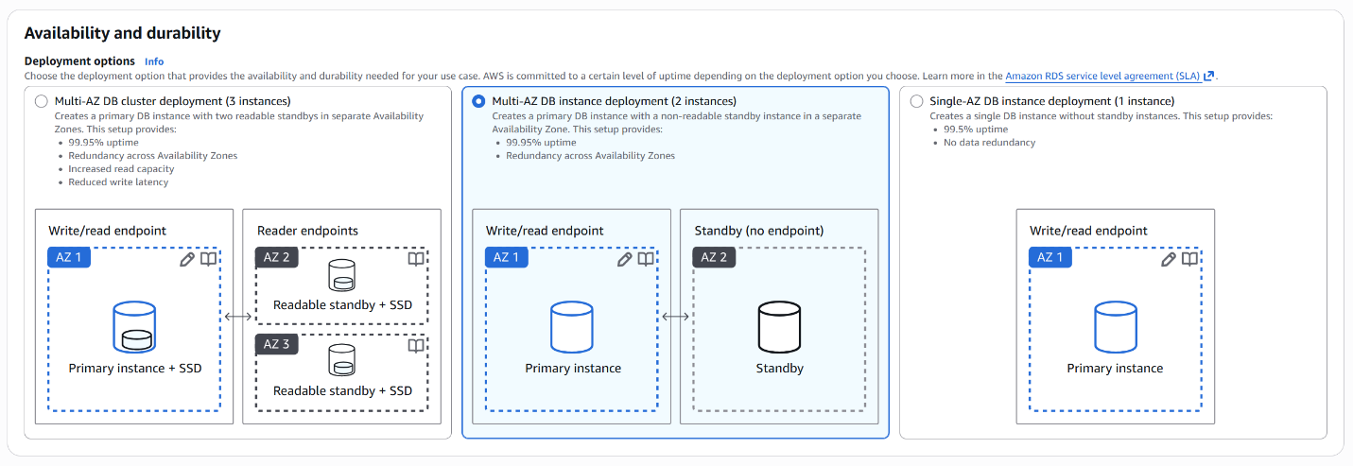
Under Deployment options, select either one of the multi-AZ DB instance deployment options. In this case, it does not matter which option is chosen as long as a multi-AZ DB instance deployment option is chosen.

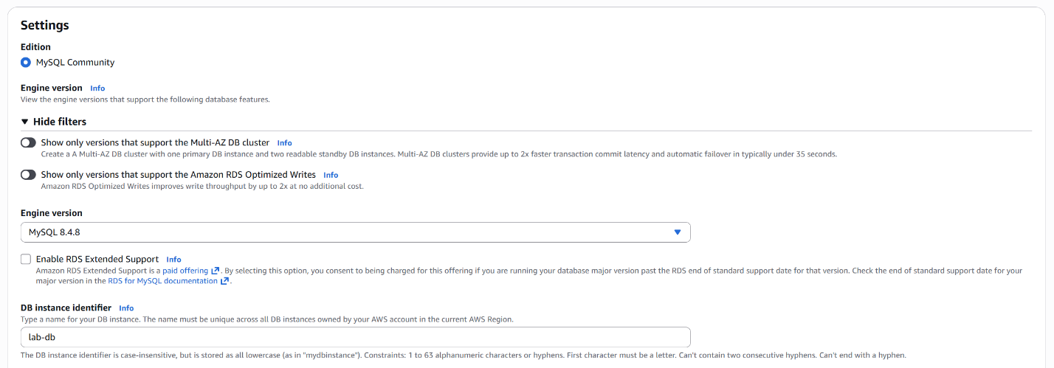
Under DB instance identifier, type in lab-db.

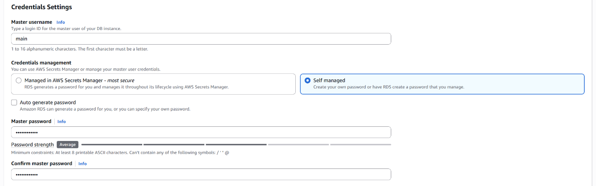
Under Master username, type main. Select Self-managed under Credential management. Then, set the password to lab-password. Do this by typing the password under Master password and Confirm master password.

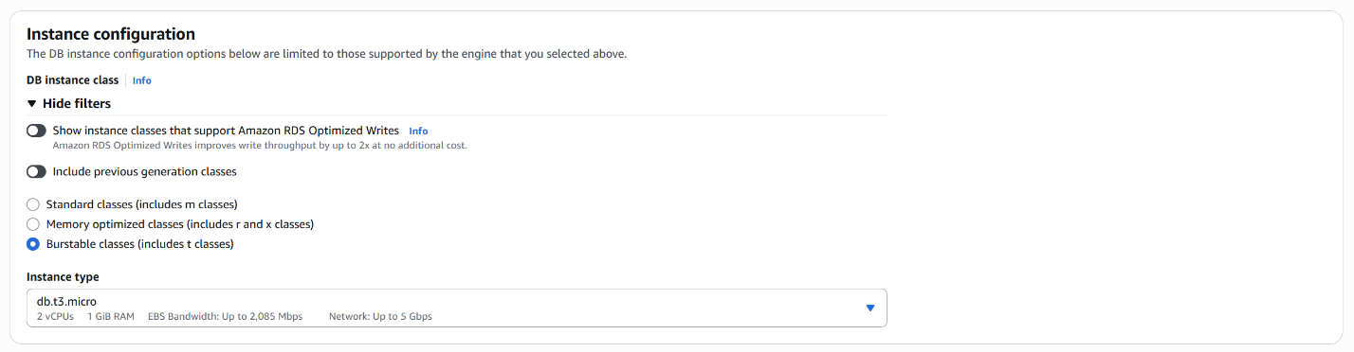
Then under DB instance class, select Burstable classes. Under Instance type, select db.t3.micro.

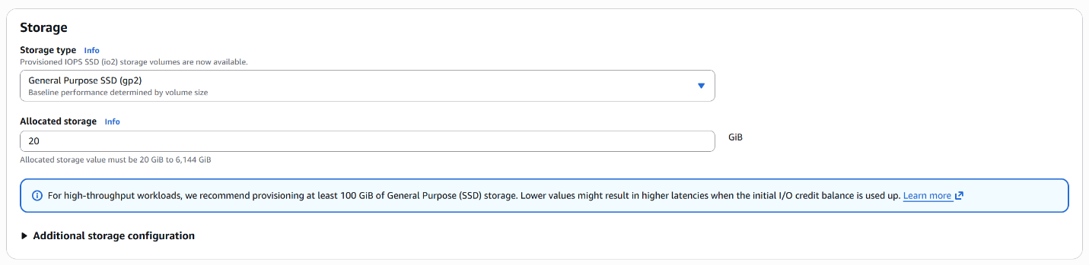
Under Storage type, select General Purpose SSD (gp2). Under Allocated storage, type in 20.

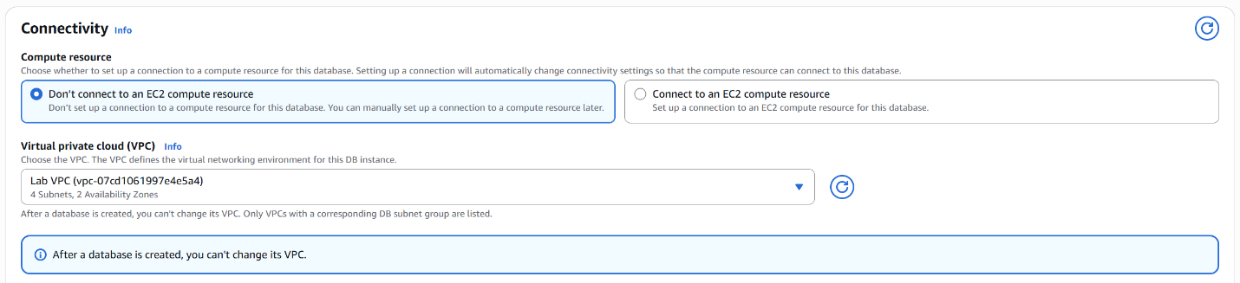

Under Compute resource, make sure Don’t connect to an EC2 compute resource is selected. Then, select Lab VPC under Virtual private cloud (VPC).

Next, deselect default for the chosen VPC security group. Do this by clicking the Choose one or more options clicking the checkbox for default to deselect it.

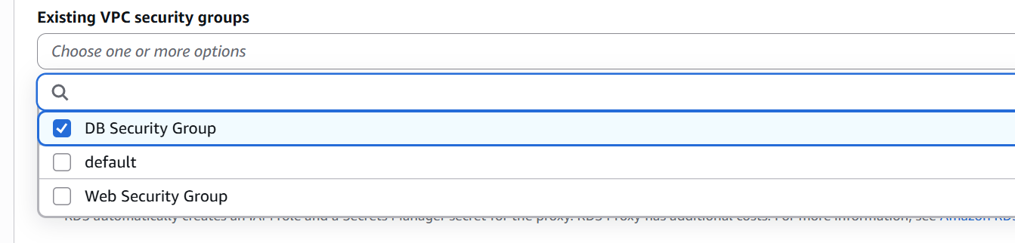
Then select DB Security Group.

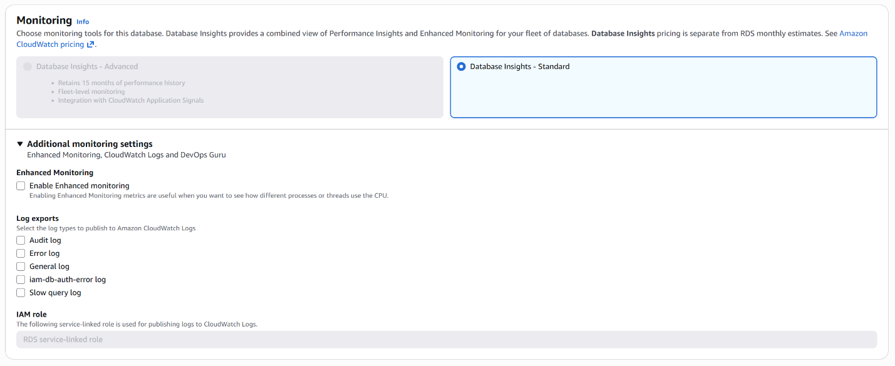
Under Enhanced Monitoring, deselect Enable Enhanced monitoring.

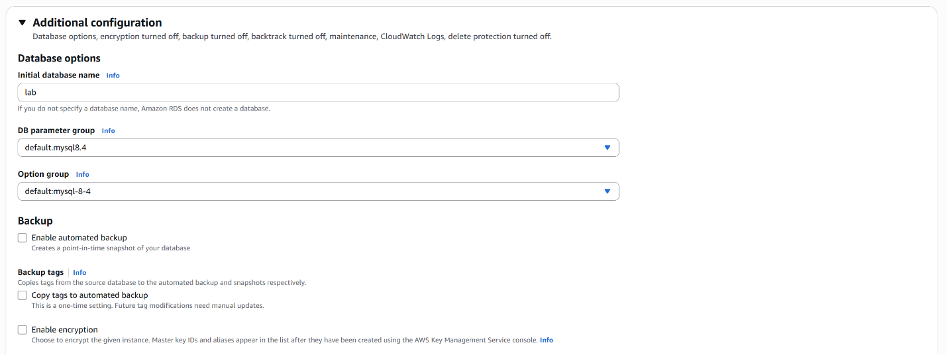
Under Initial database name type lab.


Then, click Create database.

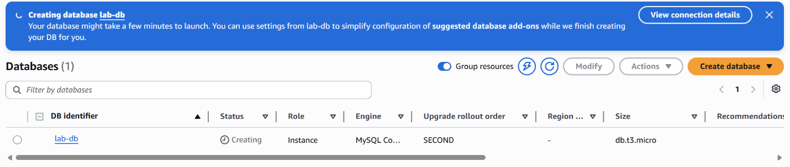
A banner will appear notifying you that the database is being created. Wait a couple of minutes.

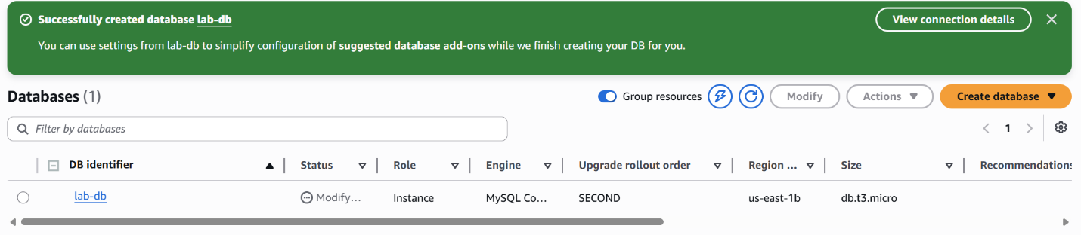
Once the blue banner becomes green, click lab-db which is a link.

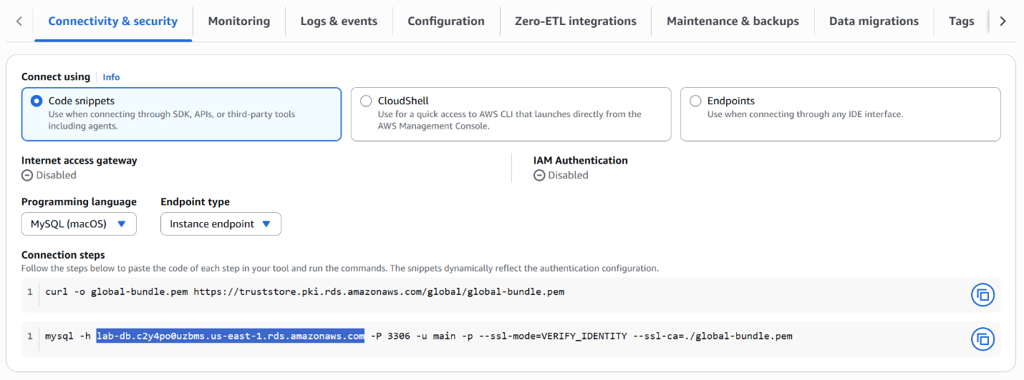
Scroll down and copy the link to the database. It should look like lab-db.xxxx.us-east-1.rds.amazonaws.com.

Next, navigate back to the lab instructions. Click AWS Details.
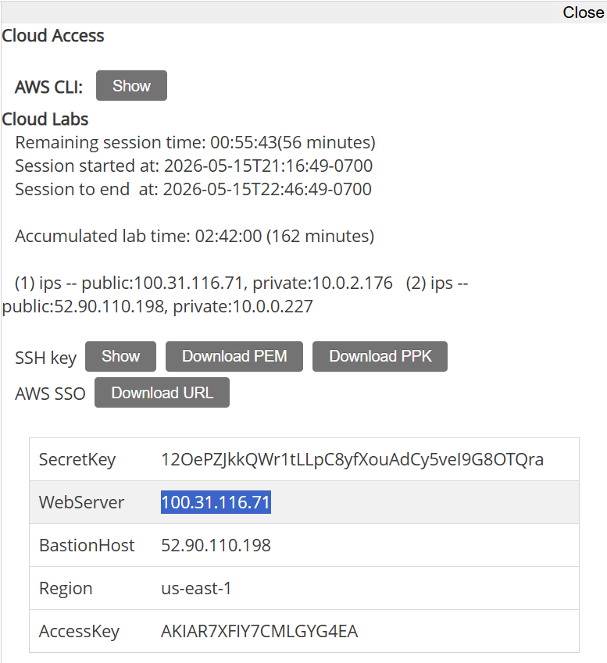
Copy the IP to the WebServer.

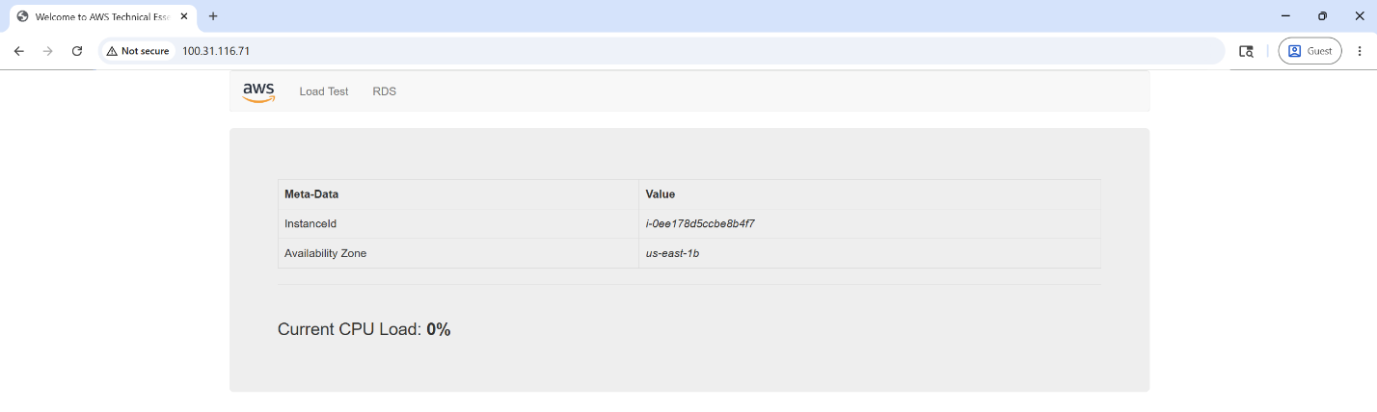
Paste IP address into a new browser. Select the RDS tab.

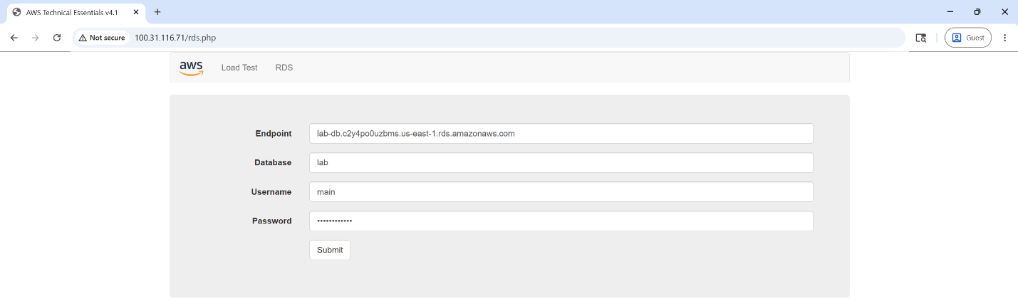
Here, paste the link from the database in the input for Endpoint. Type lab for the Database input. Type main for the username. And type lab-password for the password input. Then, click submit.

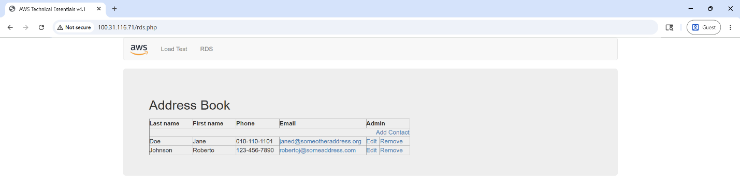
Success! You have accessed the Relational Database and can see its contents!

Scale and Load Balance Your Architecture
In this lab, you will set up an autoscaling system and a load balancing system that will detect increases in CPU load and automatically adjust based on traffic.
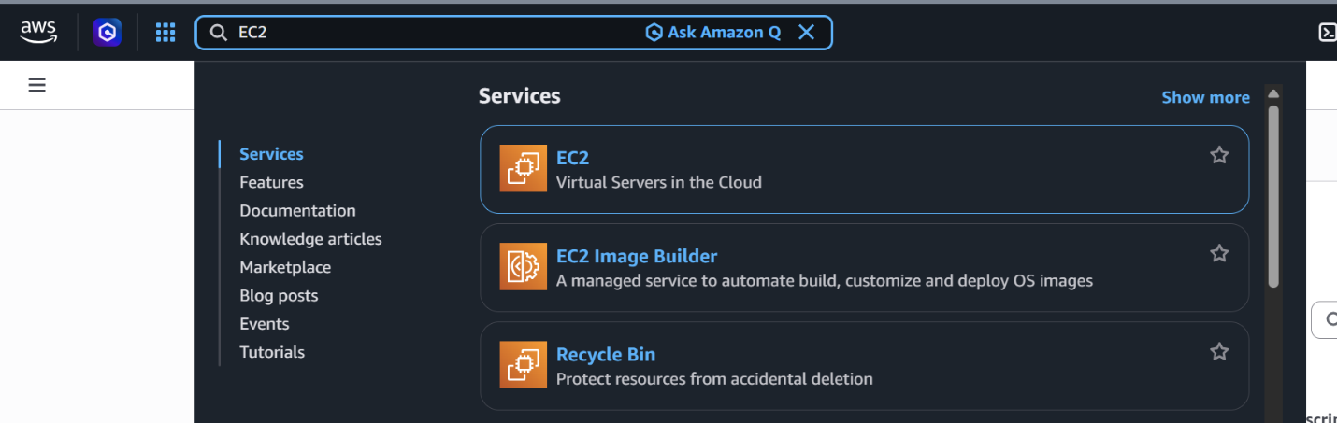
First, type EC2 into the main search bar and select the EC2 service.

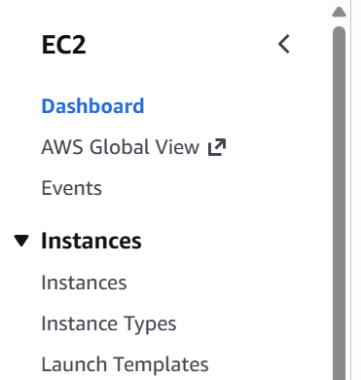
Next, select instances, under Instances in the left-side bar.

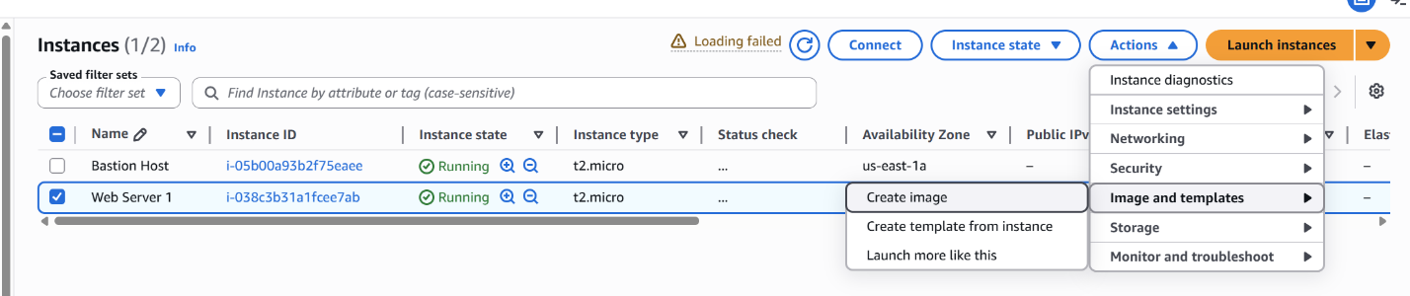
Then select Web Server 1, then click Actions. Under the dropdown menu, select Image and templates and then Create image.

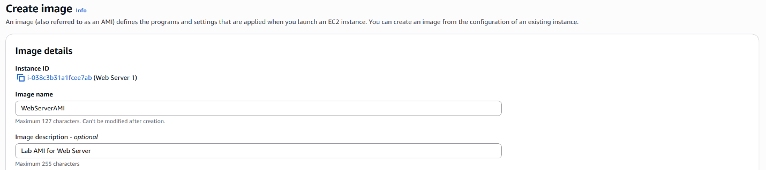
Type in WebServerAMI as the Image name. Type in Lab AMI for Web Server under Image description.

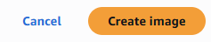
Then, click Create image.

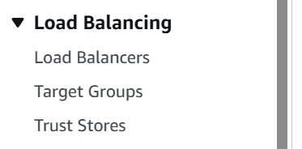
Back to the left-side bar, select Target Groups under Load Balancing.

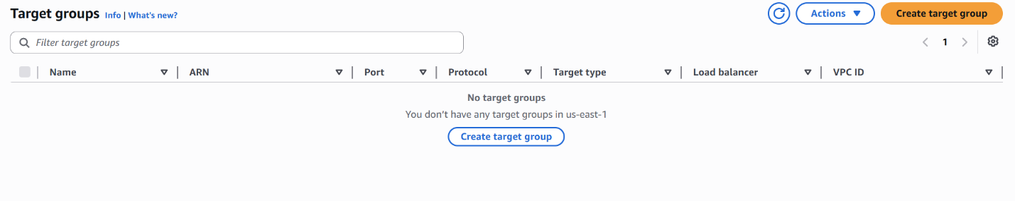
Then, click Create target group in the Target groups menu.

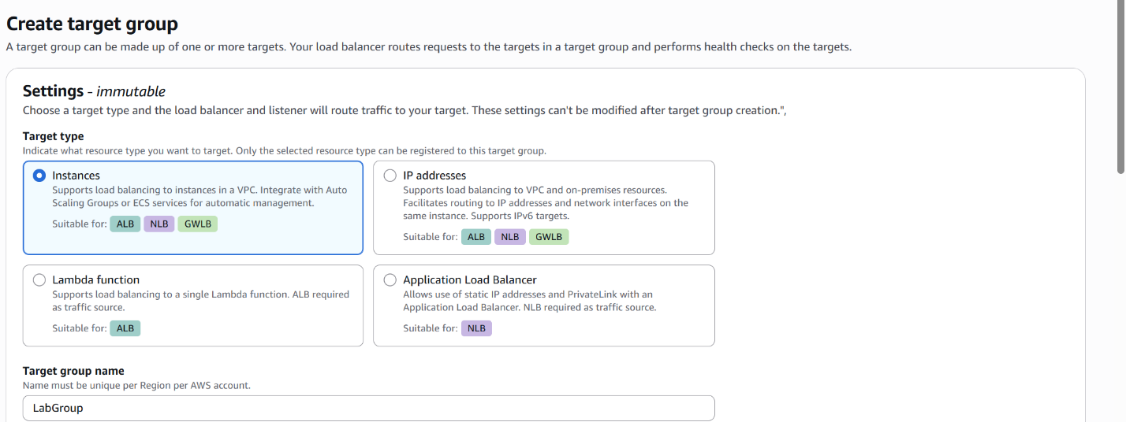
Make sure Instances is selected as the Target type and type in LabGroup as the Target group name.

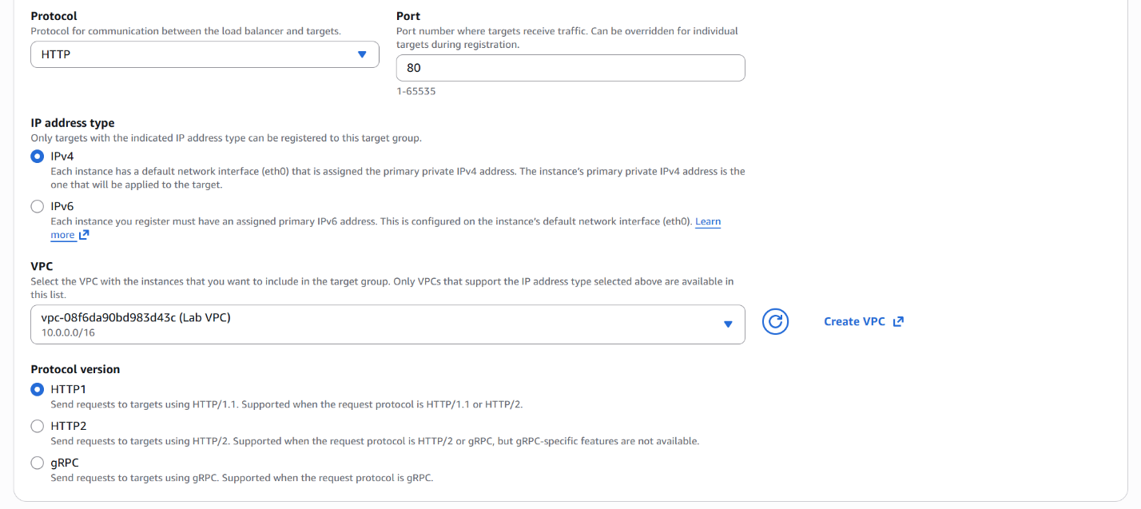
Then select Lab VPC under the VPC tab.

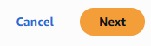
Scroll down and click next.


For the next tab, scroll down and also click next.

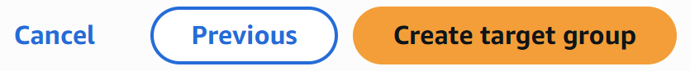
And for the next tab, click Create target group.
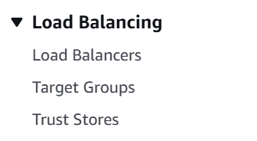
Now navigate back to the left-side bar and click Load Balancers under Load Balancing.

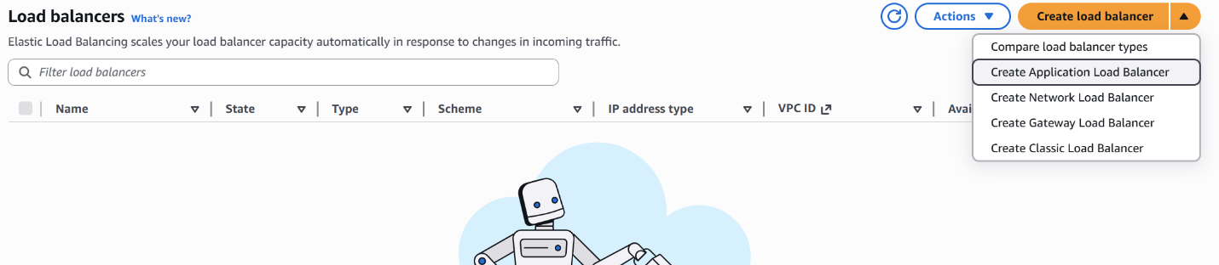
Now in the Load Balancers menu, click Create load balancer and Create Application Load Balancer from the drop-down menu.

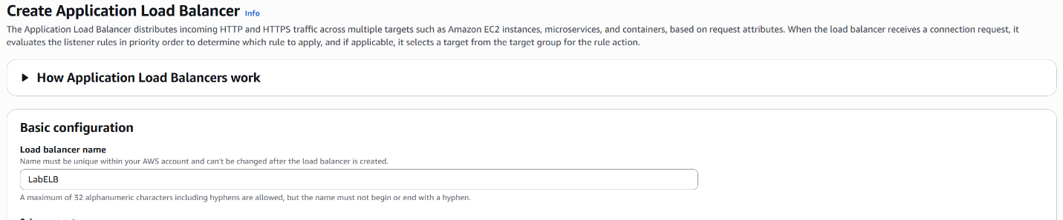
Type in LabELB as the Load balancer name.

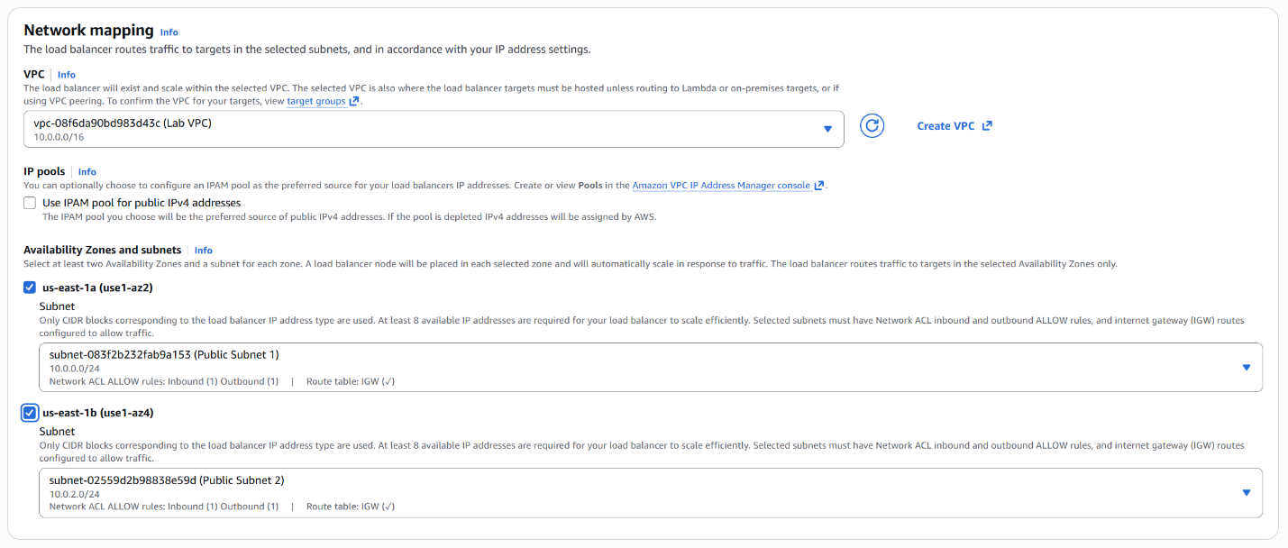Make sure Lab VPC is selected for VPC. Under Availability Zones and subnets, select both us-east-1a and us-east-1b. Select Public Subnet 1 and 2 for each respectively.

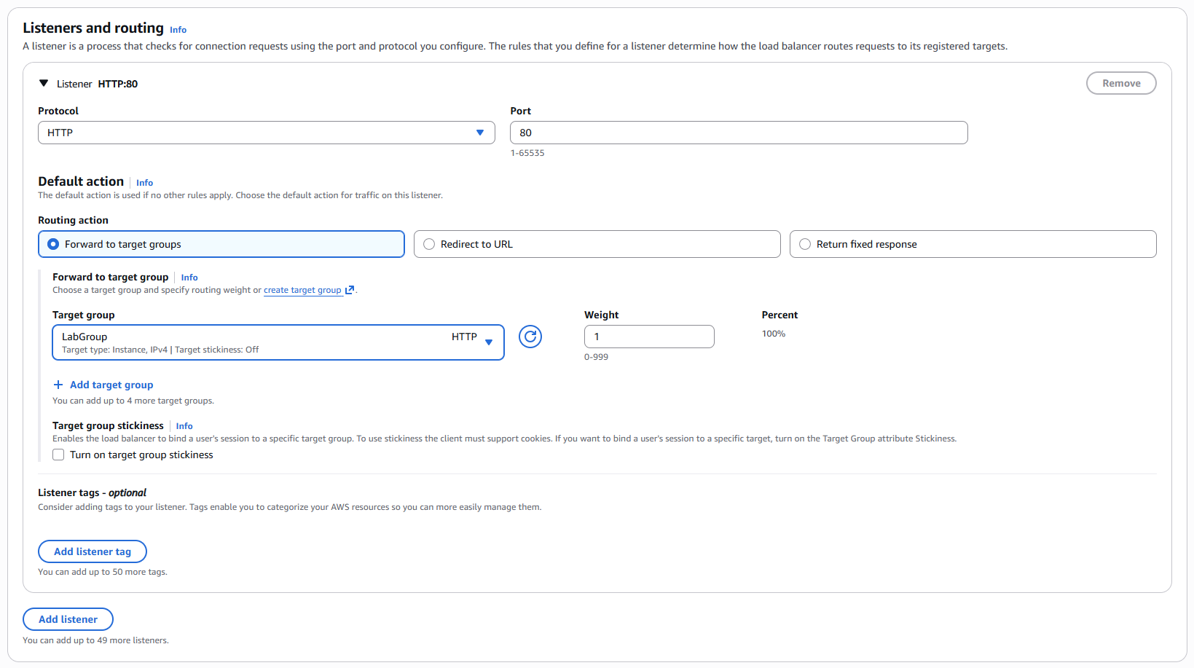
Under Target group, make sure LabGroup is selected.

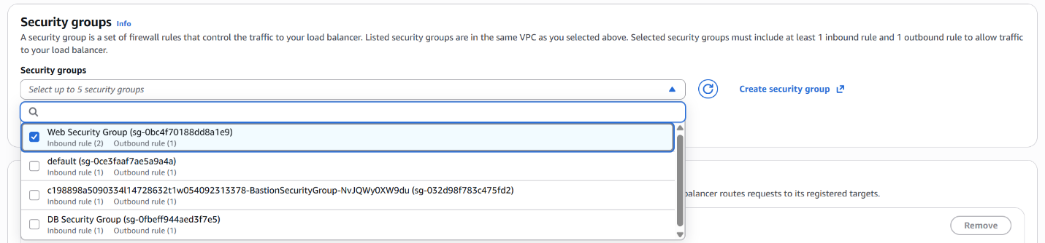
Under Security groups, deselect default and select Web Security Group.


Then, click Create load balancer.

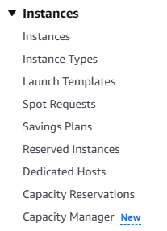
Under Instances from the left-side bar, select Launch Templates under Instances.

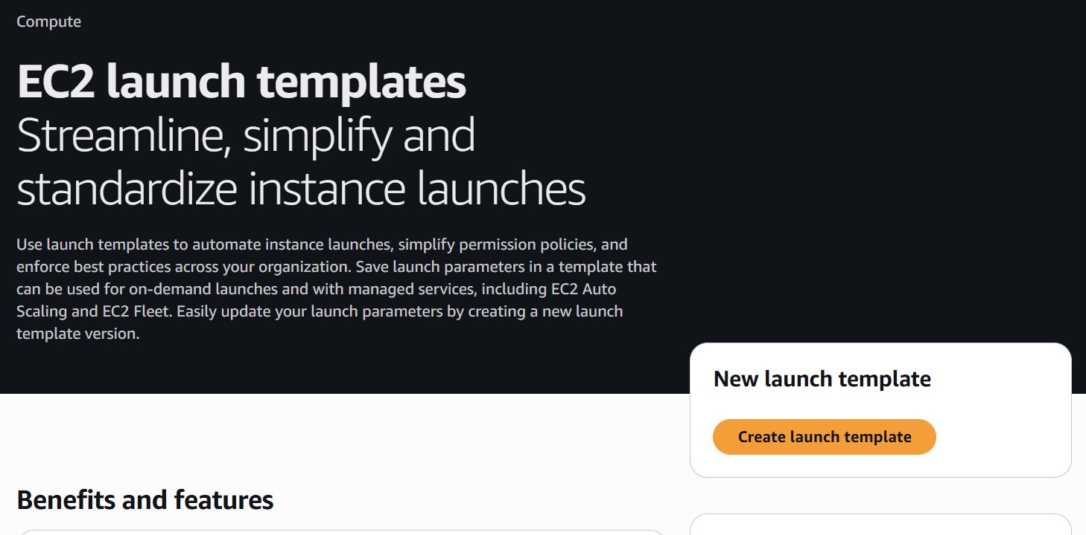
Then, click Create launch template.
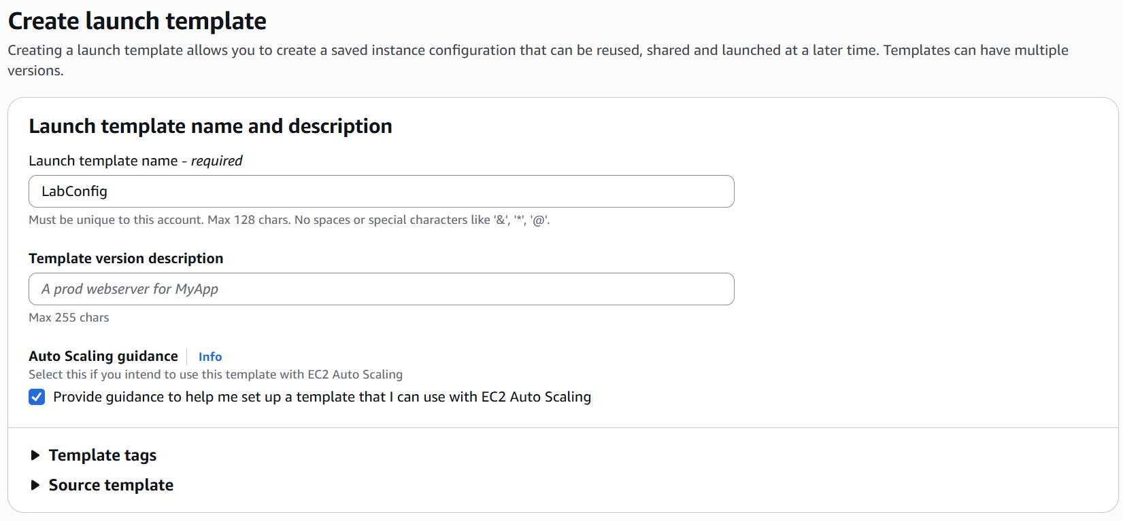
Type in LabConfig as the Launch template name. Check the box for Provide guidance to help me set up a template that I can use with EC2 Auto Scaling.

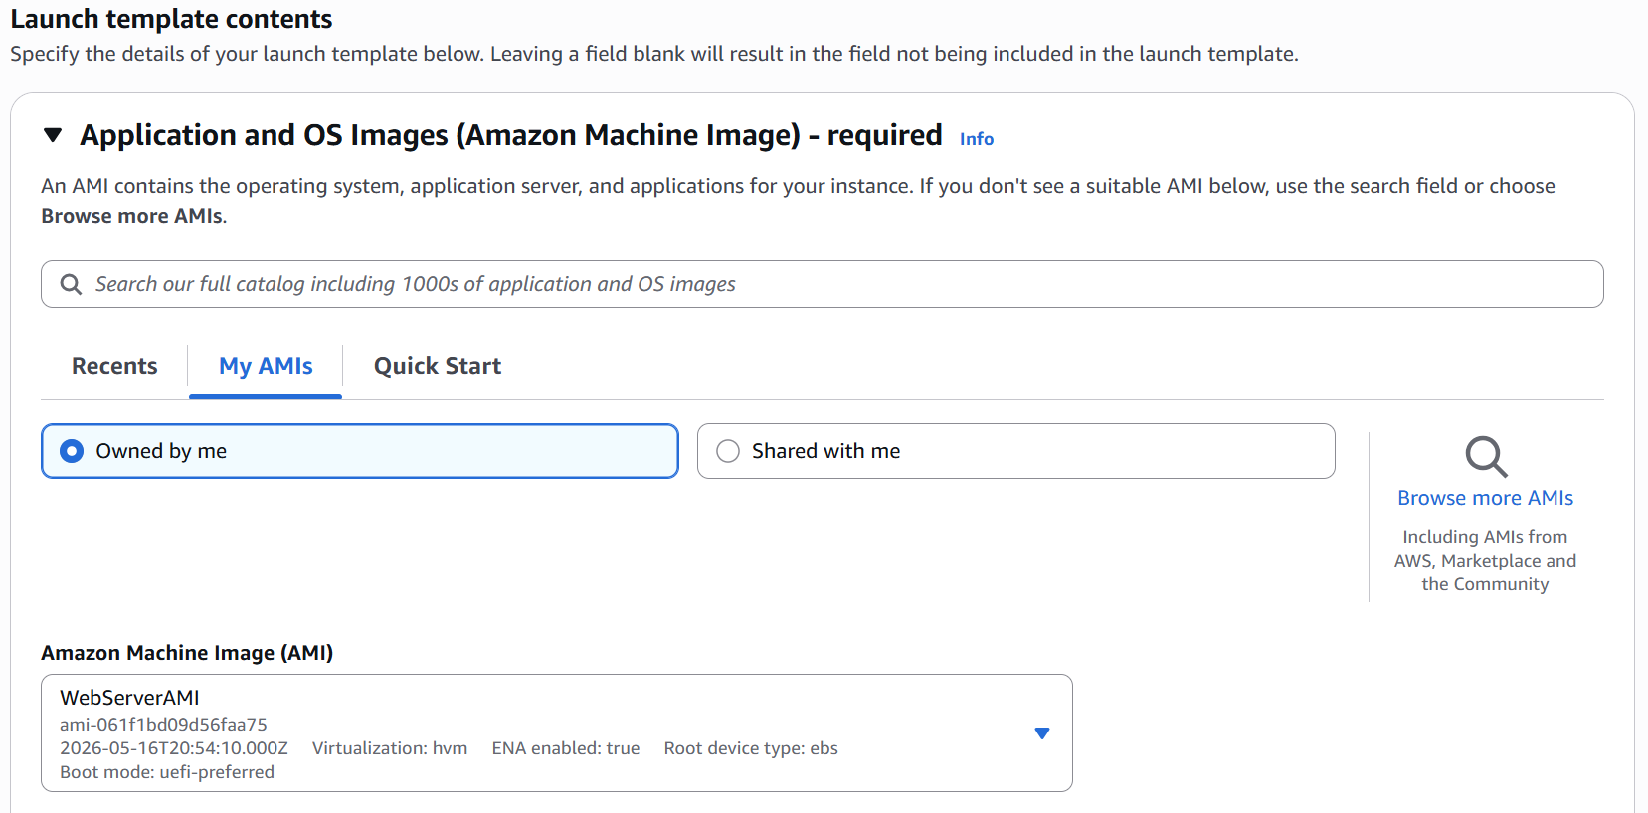
Making sure the My AMIs tab is selected and the Owned by me icon is selected, select WebServerAMI as the Amazon Machine Image (AMI).

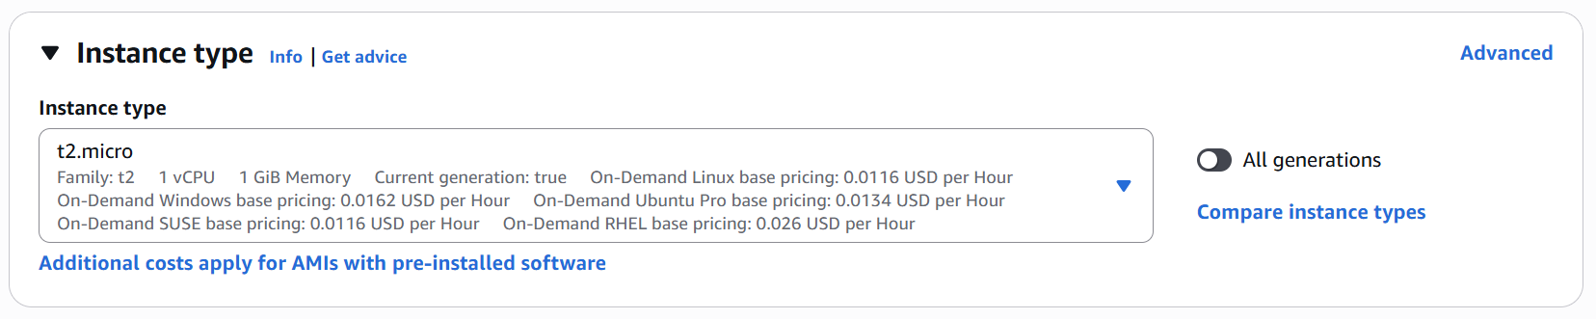
Under Instance type, select t2 micro.

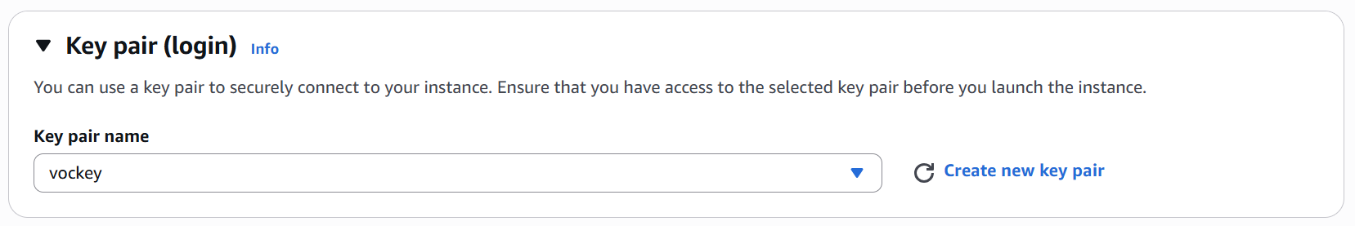
Under Key pair name, select vockey.

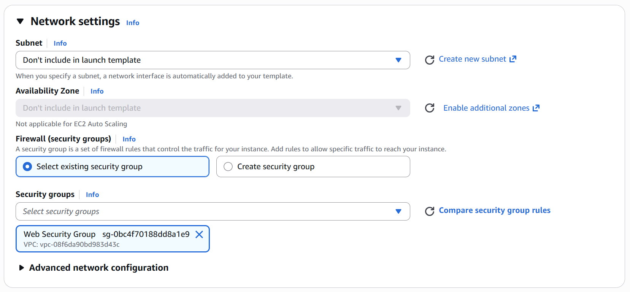
Under Firewall, make sure Select existing security group is selected. Under Security groups make sure to deselect default and select Web Security Group.

Expand Advanced details.

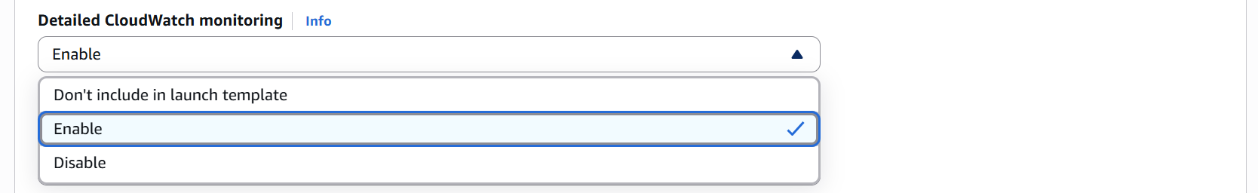
Scroll down to Detailed CloudWatch monitoring and select Enable.

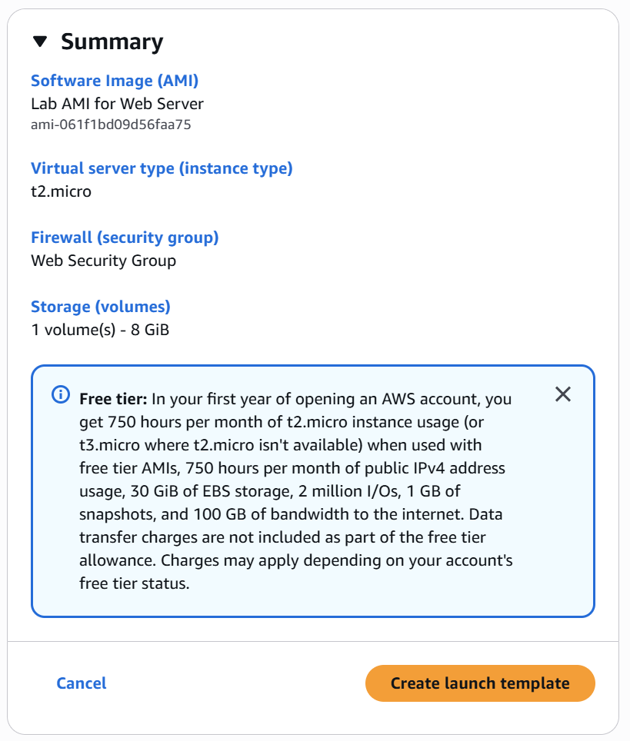
Then, on the side, click Create launch template.

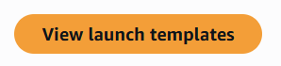
Then click View launch templates.

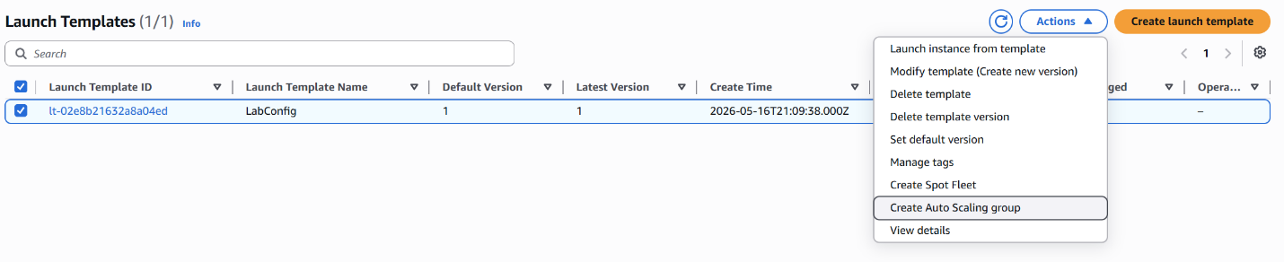
Under Launch Templates, select the LabConfig Template. Then click Actions and Create Auto Scaling group from the dropdown menu.

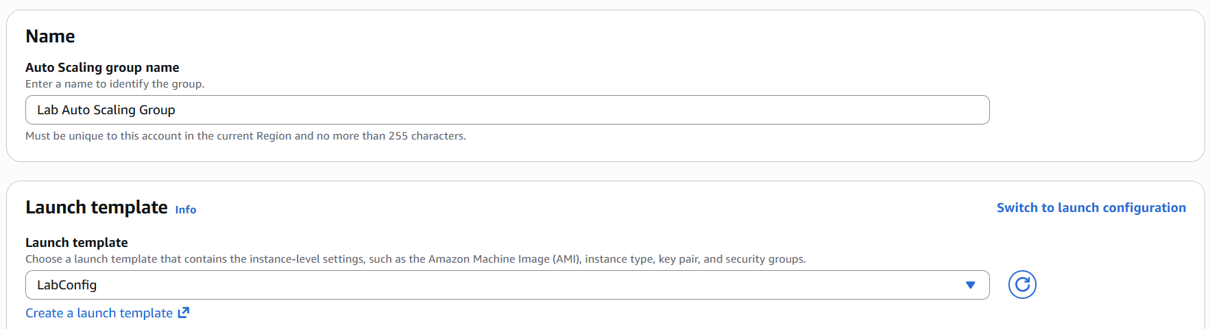
Type in Lab Auto Scaling Group as the name. Then select LabConfig as the Launch template.


Then, click Next.

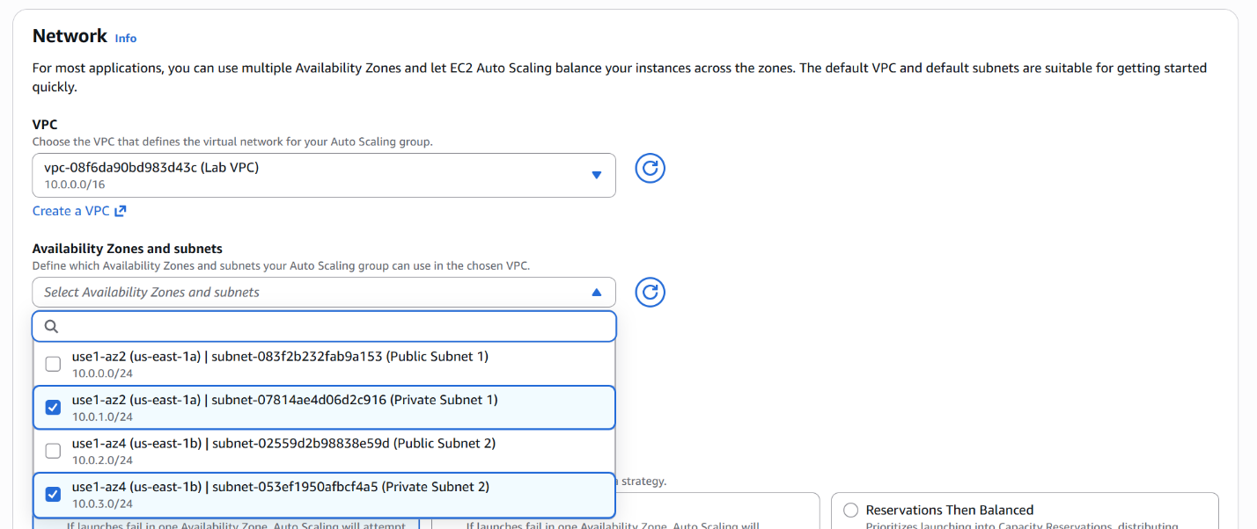
Then, select Lab VPC as the VPC. Under Availability Zones and subnets, select Private Subnet 1 and 2.

Scroll down and click Next.

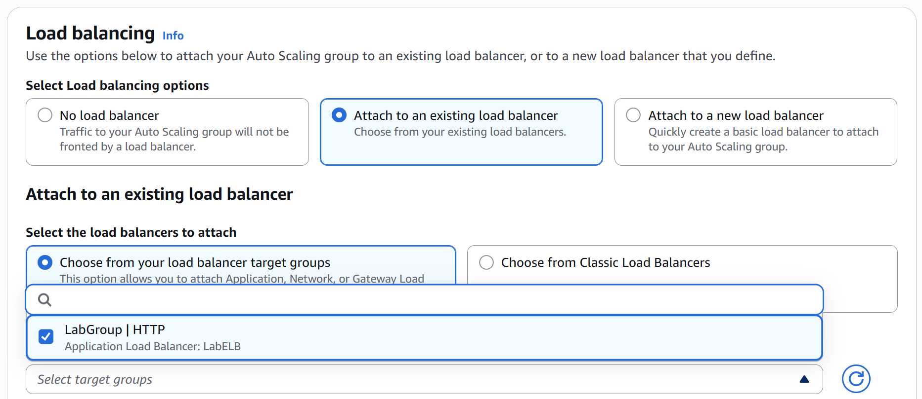
Next, select Attach to an existing load balancer. Then select Choose from your load balancer target groups. Then select LabGroup from clicking Select target groups.

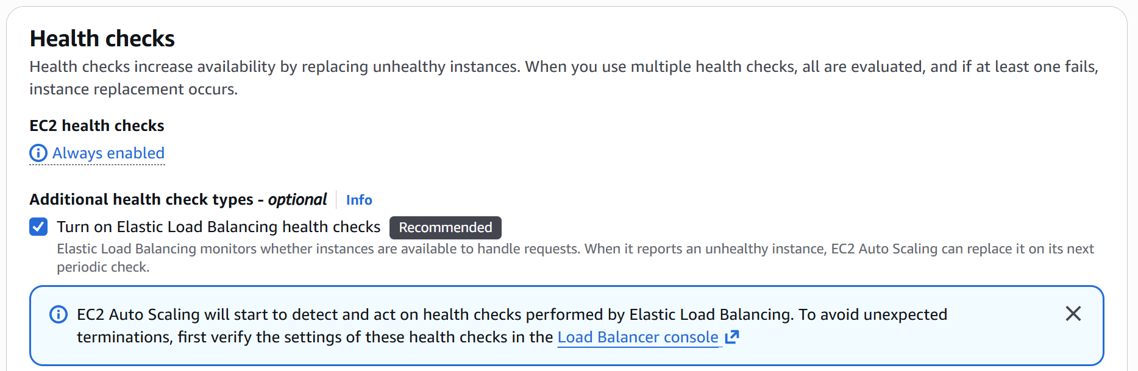
For CloudWatch to work, you must select Turn on Elastic Load Balancing health checks.

Then, click Next.

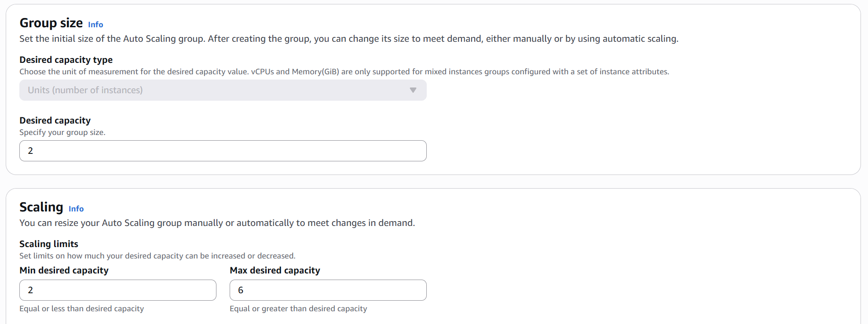
Next, type in 2 as the desired capacity. Then for the min desired capacity and max desired capacity, type in 2 and 6 respectively.

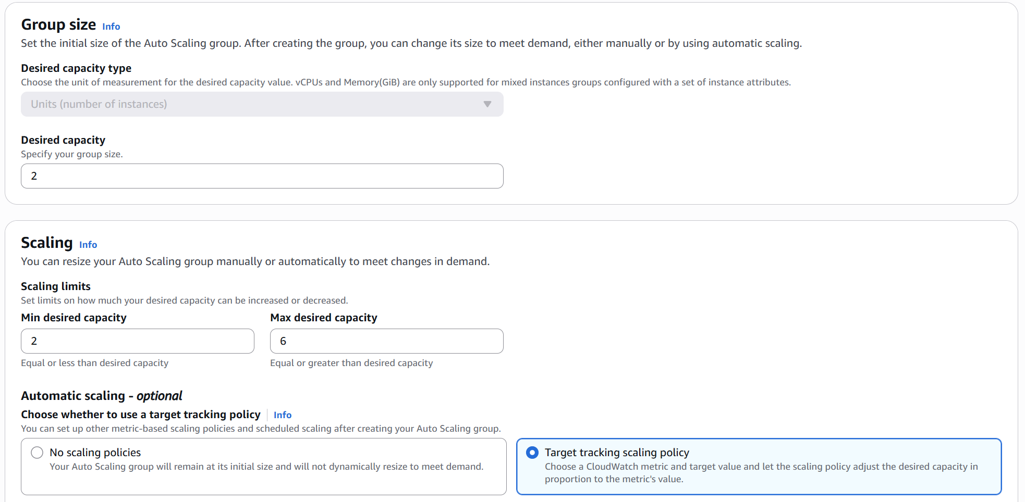
Select Target tracking scaling policy.

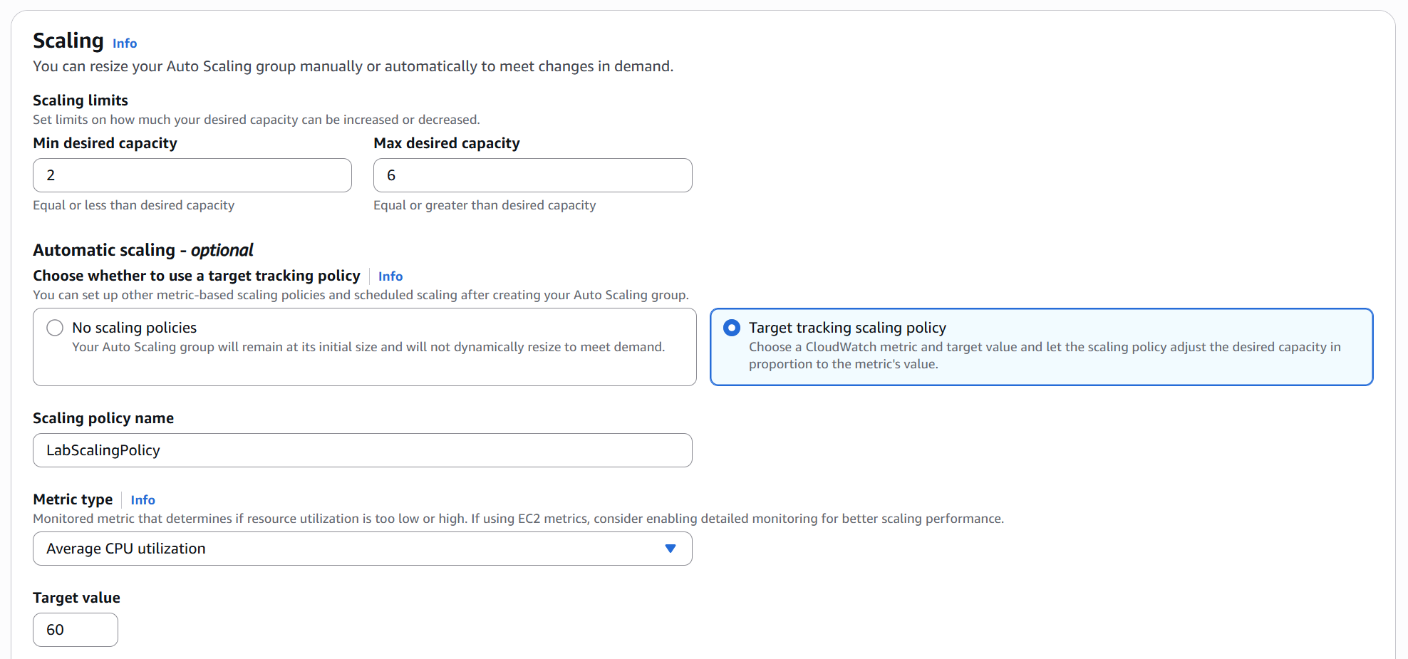
Name the policy LabScalingPolicy. Under Metric type, make sure Average CPU utilization is selected. Set the Target value to 60.

Then, click Next until you get to the tag menu.

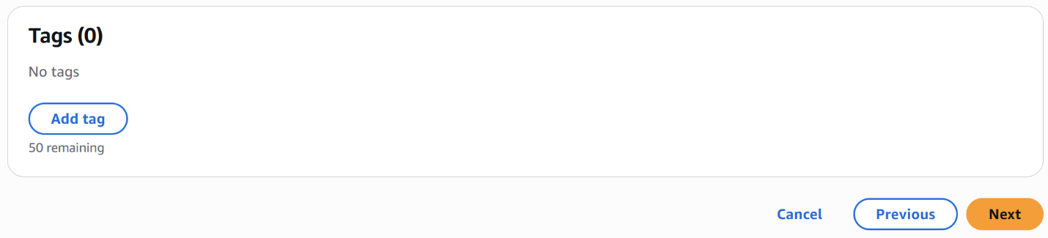
Under Tags, click Add tag to create a new tag.

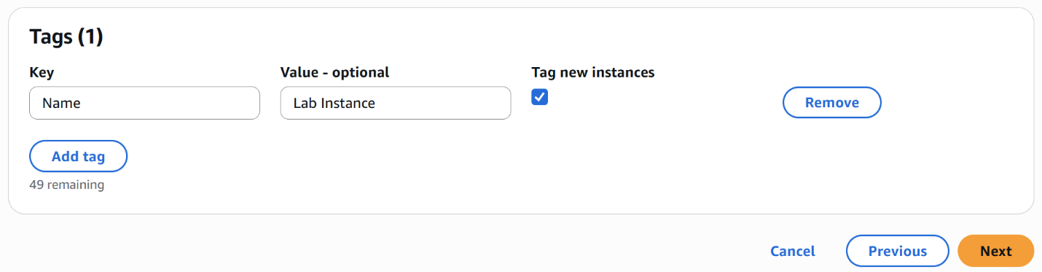
Under Key, type Name. Under Value, type Lab Instance. Then click Next.

On the review page, click Create Auto Scaling group.

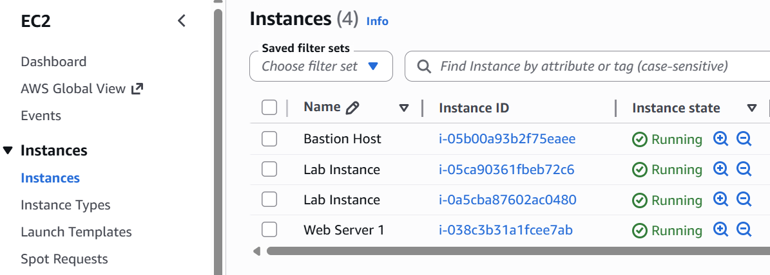
Something cool you should see is the creation of a second Lab Instance from the autoscaling.

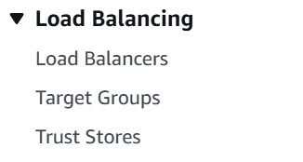
Next, we move onto load balancing. Select Load Balancers from the left-side bar.

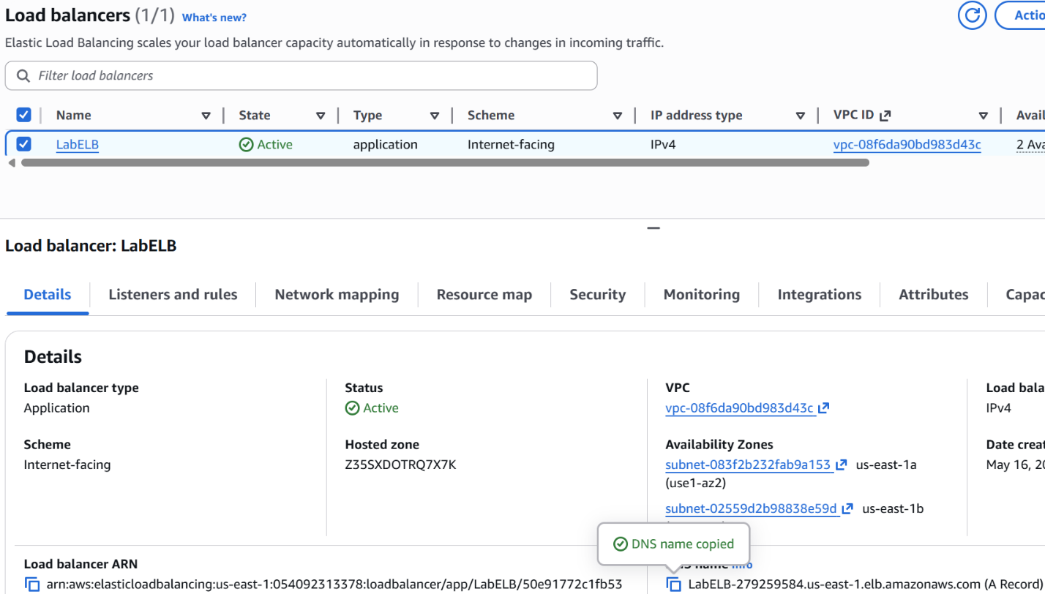
Select LabELB and copy the DNS name from the Details tab.

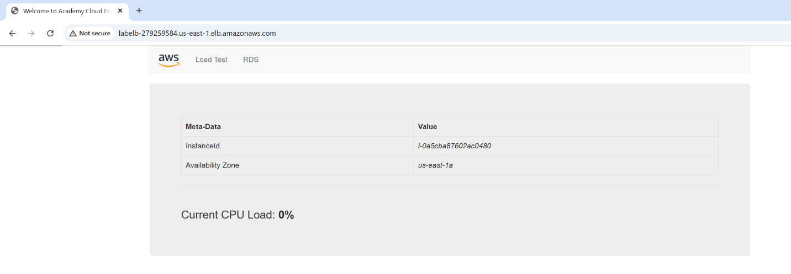
Paste in the link and select the Load Test tab. From here you can navigate to the CloudWatch tab to see alarms being set off in action. Success, you have completed Lab 6: Scale & Load Balance your Architecture.

Problems

For this lab I did not have many problems. Some minor mistakes occurred when inputting values for the load balancers and launch templates. From my mistakes I have learned that making sure to check your configurations before creating the object is of utmost importance.
I learned about the different ways misconfigurations can affect the entire system. For instance, without target groups, many services like CloudWatch and AWS ELB would not be able to directly target the EC2 instances which would lead to multiple problems. First, the configuration would malfunction as the services are not set properly, Second, if the configuration was allowed, during times of high traffic, CloudWatch would not detect any spike in traffic and would not trigger autoscaling or load balancing to help manage the flow of traffic.

Conclusion

From these labs, users should be able to create, analyze, and experiment with multiple AWS services including the ability to manipulate the EC2 service using advanced techniques. Users have also gained the ability to use services in conjunction with each other create a similar system that mirrors on-premises data centers.

